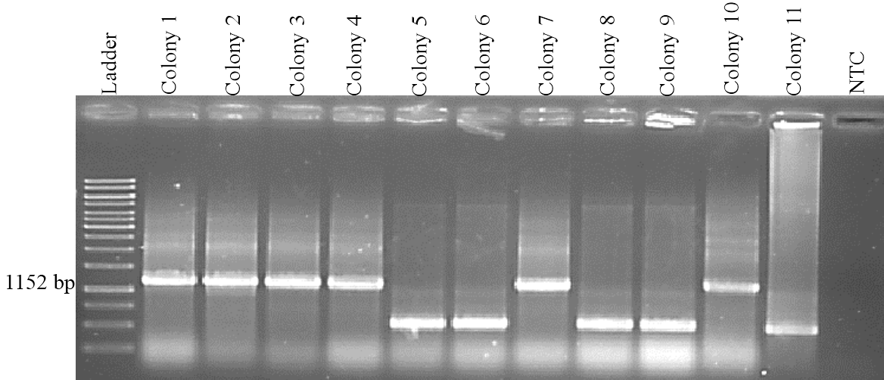

Figure 1: Colony PCR using M13 primers. PCR product size 1152 bp indicated the positive colonies.

Ladder 1kb (fermentas, Cat#:SM0311), NTC (Non Template Control)

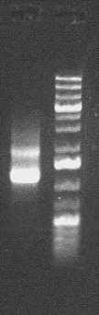

Figure 2: Transposon mRNA after DNase treatment (ladder 1kb Plus)

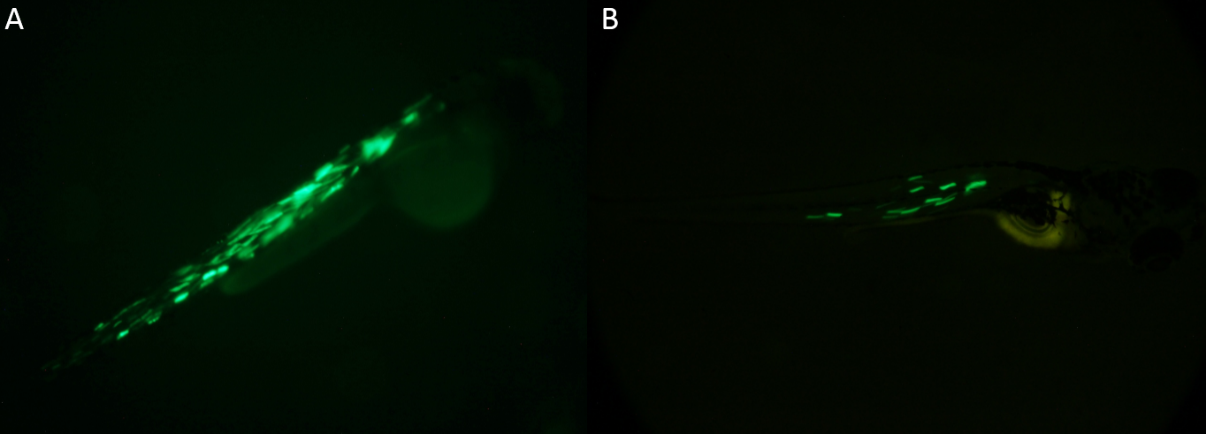

Figure 3: Mosaic expression. (A) High expression. (B) Low expression.

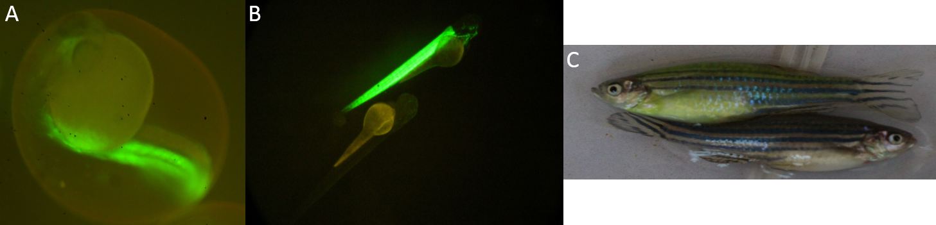

Figure 4: Microscopic evolution of embryos. (A) 2 dpf embryos. (B) 5 dpf embryos. (C) Adult wild type and Tg(mylpfa:egfp) zebrafish

**Table1:** Different concentrations of constructs microinjection

|  |  |  |  |  |
| --- | --- | --- | --- | --- |
| GFP Positive | Live | Dead | Total | Concentration |
| 0 | 166 | 16 | 182 | **Low** |
| 18 | 101 | 41 | 142 | **Moderate** |
| 0 | 3 | 131 | 134 | **High** |