**Cover letter**

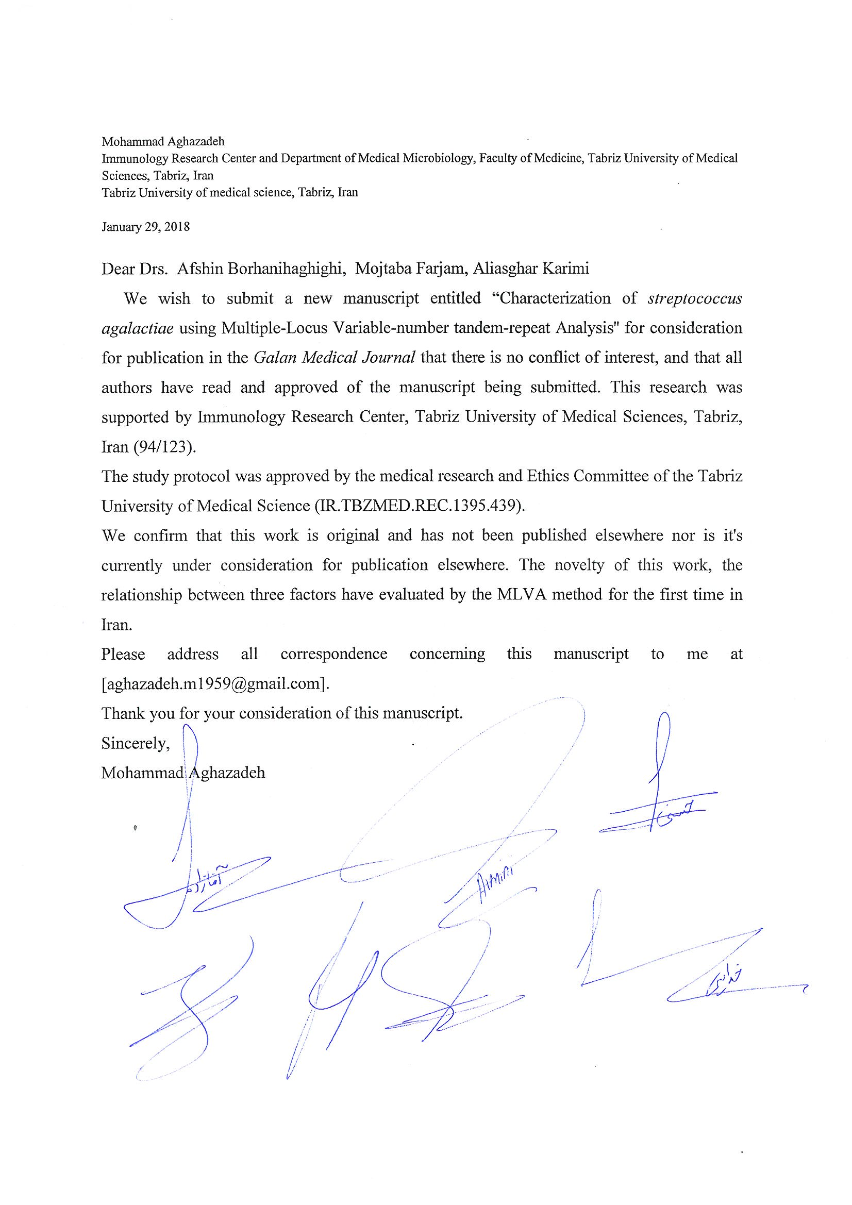

**Title page**

**Characterization of *streptococcus agalactiae* using Multiple-Locus Variable-number tandem-repeat Analysis**

Running title: Efficiency of MLVA typing method for *S. agalactiae*

Farzaneh Khodaei1, Behrooz Sadeghi Kalani2, Naser Alizadeh3, Alka Hassani1, Mohammad Najafi4, Enayatollah Kalantar5, Abbas Amini6, Mohammad Aghazadeh1

1Immunology Research Center, Department of Medical Microbiology, Faculty of Medicine, Tabriz University of Medical Sciences, Tabriz, Iran.

2Department of Medical Microbiology, Iran University of Medical Sciences, Tehran, Iran

3Department of Medical Microbiology, Tabriz University of Medical Sciences, Tabriz, Iran

4Department of Biochemistry, Iran University of Medical Sciences, Tehran, Iran

5Department of Microbiology and Immunology, School of Medicine, Alborz University of Medical Sciences, Karaj, Iran.

6School of Computing, Engineering and Mathematics, University of Western Sydney, Kings wood, NSW 2751, Australia

Corresponding author: Mohammad Aghazadeh

Mailing address: Department of Medical Microbiology, Faculty of Medicine Tabriz University of Medical Science, Golgasht Street, Tabriz, Iran

E-mail address:m.aghazadeh1959@gmail.com

Telephone: +98-4133364661

Fax number: +98-4133364661

Total number of pages: 13

Total number of photographs: 2

Total number of tables: 2

Word count for abstract: 220

Word count for text: 2651

Acknowledgments

This research was supported by Immunology Research Center, Tabriz University of Medical Sciences, Tabriz, Iran (94/123).We thank Dr. Nejadeh (Nejadeh laboratory, Varamin, Tehran, Iran) and Mr. Esmail Sharifi (Laboratory expert, Fardis Central Laboratory, Fardis, Karaj, Iran) for collecting isolates for this study.

**Table 1.** MLVA primers, copy number, number of alleles and index of diversity (D)

|  |  |  |  |  |  |  |  |  |  |
| --- | --- | --- | --- | --- | --- | --- | --- | --- | --- |
| No | Sequence (5'->3') | Period Size | Copy Number | No. of alleles | K-value4 | Hunter-Gaston diversity index3 | | Simpson’s diversity index1 | |
| CL2 | HGDI | CL | SDI |
| TR1 | F: TCATTATGTAAATGGTGGTGTTGA  R: TGGGTTTTATGTCCCTCTTCA | 18 | 3.8 | 4 | 11 | 0.857-0.900 | 0.878 | 0.847-0.890 | 0.869 |
| TR2 | F: TGACTGTTTGTTAGAGTCACCTTGA  R: TTTGGCTTTATATGGGAGTGC | 48 | 13.2 | 10 | 4 | 0.560-0.670 | 0.615 | 0.553-0.663 | 0.608 |
| TR3 | F: TTTGAAAAGTGTAACACTAGCTCCA  R: GGAGCATTCGTAGCTCTTGG | 159 | 4.7 | 3 | 8 | 0.760-0.841 | 0.800 | 0.751-0.832 | 0.791 |
| TR4 | F: TTTTTAACCGCCAAGTTTCC  R: CCACTGATCAAGCAAATCAA | 12 | 22.6 | 7 | 6 | 0.999-1.000 | 0.683 | 0.619-0.732 | 0.676 |
| TR5 | F: GTTGATAAAGTTGATGTTCCG  R: AGCCTTCTTCAACTATAGGTG | 18 | 5.8 | 6 | 91 | 0.999-1.000 | 1.000 | 0.949-0.950 | 0.989 |

1. SID: Simpson's diversity index

2. CI: Confidence Intervals

3. HGDI: Hunter-Gaston diversity index

4. K-value: Number of different repeats present at each locus in this sample set

**Table 2:** Presents the relationships between Characterization of GBS using Multiple-Locus Variable-number tandem-repeat Analysis

|  |  |  |  |  |  |  |  |
| --- | --- | --- | --- | --- | --- | --- | --- |
| **Origin of isolates (No. Of isolates)** | | | | | MLVA genotypes | Serotyes | Erythromycin resistance phenotype |
| Blood  (N=13) | Vaginal carriage  (N=34) | Urinary  tract infections in women  (N=13) | Spermatic fluid  (N=4) | Pregnant women  (N=26) |
|  |  | 1 |  |  | 2 | III | cMLSB1 |
|  | 1 |  |  |  | 4 | III | M3 |
|  |  |  |  | 1 | 5 | III | L4 |
|  | 1 |  |  |  | 6 | V | L |
| 1 |  |  |  |  | 6 | V | M |
| 1 |  |  |  |  | 6 | III | M |
|  |  |  |  | 1 | 6 | V | cMLSB |
|  |  | 1 |  |  | 6 | V | cMLSB |
| 1 |  |  |  |  | 8 | V | M |
|  |  | 1 |  |  | 8 | V | cMLSB |
|  | 1 |  |  |  | 10 | III | cMLSB |
|  | 1 |  |  |  | 13 | III | cMLSB |
|  |  |  |  | 1 | 14 | II | L |
|  | 1 |  |  |  | 15 | III | cMLSB |
|  | 1 |  |  |  | 16 | III | cMLSB |
|  | 1 |  |  |  | 16 | III | cMLSB |
|  | 1 |  |  |  | 16 | III | cMLSB |
| 1 |  |  |  |  | 16 | III | cMLSB |
|  | 1 |  |  |  | 16 | III | L |
| 1 |  |  |  |  | 20 | III | M |
| 1 |  |  |  |  | 21 | III | iMLSB2 |
|  |  |  |  | 1 | 26 | III | L |
| 1 |  |  |  |  | 28 | III | L |
|  | 1 |  |  |  | 28 | III | M |
|  |  |  |  | 1 | 30 | III | M |
|  |  |  |  | 1 | 31 | III | M |
|  |  |  |  | 1 | 34 | III | M |
| 1 |  |  |  |  | 34 | III | L |
|  | 1 |  |  |  | 38 | V | iMLSB |
|  | 1 |  |  |  | 40 | III | cMLSB |
|  |  | 1 |  |  | 43 | II | cMLSB |

1. cMLSB phenotype: resistance to both erythromycin and clindamycin
2. iMLSB phenotype: resistance to erythromycin, susceptibility to clindamycin (positive D test)
3. M phenotype: resistance to erythromycin, susceptibility to clindamycin (negative D test)
4. L phenotype: susceptibility to erythromycin, resistance to clindamycin

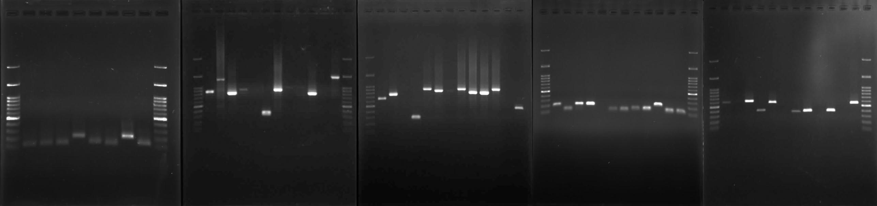

**Figure 1:** The polymorphism of Five VNTRs is shown by agarose gel electrophoresis of PCR products.

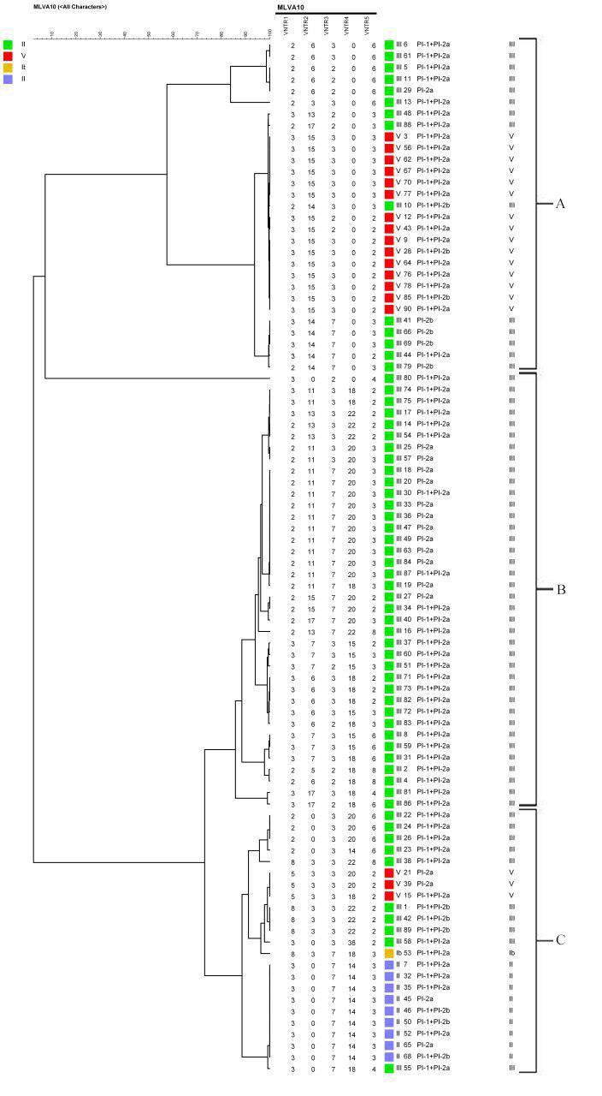

**Figure2:** Cluster analysis of 90 *S. agalactiae* isolates using the UPGMA (unweighted-pair group method using average linkages) algorithm, generated with Bionumerics 6.0 software**.** Clusters are classified on the basis of the level of genetic relatedness, serotypes and pilus island genes.