Table1. Hub-bottleneck proteins with significant centrality values based on Degree and Betweenness parameters

|  |  |  |  |
| --- | --- | --- | --- |
| **Uniprot ID** | **Protein name** | **Degree** | **Betweenness Centrality** |
| **P69201** | **UB-EP52** | **22** | **0.24** |
| **Q4Q259** | **Elongation factor 2** | **22** | **0.08** |
| **Q4Q4U5** | **Chaperonin subunit alpha** | **21** | **0.07** |
| **P12077** | **Heat shock 70- related protein 4** | **16** | **0.05** |
| **Q4QBZ6** | **tubulin beta chain** | **14** | **0.08** |
| **Q4Q1M0** | **Chaperonin Hsp60, mitochondrial** | **14** | **0.01** |
| **Q4QFL8** | **ENOL** | **13** | **0.10** |
| **Q4QGC5** | **tubulin alpha chain** | **10** | **0.02** |
| **Q4Q7Y7** | **LACK2** | **10** | **0.02** |

Table 2. Biological process enrichment of clusters by PANTHER.

|  |  |  |  |  |  |
| --- | --- | --- | --- | --- | --- |
| **PANTHER GO** | **L. major (REF)#** | **#** | **Expected** | **+/ -** | **p-value** |
| **protein metabolic process** | **801** | **10** | **1.25** | **+** | **2.13E-06** |
| **Mitosis** | **175** | **3** | **0.06** | **+** | **1.36E-03** |
| **Cell Cycle** | **340** | **3** | **0.12** | **+** | **9.95E-03** |
| **Proteolysis** | **184** | **4** | **0.29** | **+** | **2.12E-02** |
| **Purine nucleobase metabolic process** | **35** | **2** | **0.03** | **+** | **3.84E-02** |

+/- Shows over- and under representations. Second and third column contains the number of genes in reference list and our list respectively. P-value threshold is considered 0.05. *L: leishmanial*

**Figure legends**

**Figure1.** Results of GO enrichment analysis related to leishmanial major were performed by PANTHER database. a): Molecular function, b): Biological process and c): Cellular component).

**Figure2.** PPI network of leishmania major based on string database and visualized by cytoscape 3.0.2 software. After visualization of network, disconnected nodes removed. Hub nodes with high degree and betweenness centrality value shows as large and yellow color nodes.

**Figure3.** The PPI Subnetworks were clustered (a, b, c) as highly connected regions in *leishmania major* protein-protein interaction network by Clusterviz (MCODE algorithm) tool in cytoscape. Green color nodes are seed nodes with highest weight.

**Figure 4.** Predicted interactions for hub-seed proteins (the red colored nodes) were obtained from STRING database (<http://string-db.org>).

Figure1

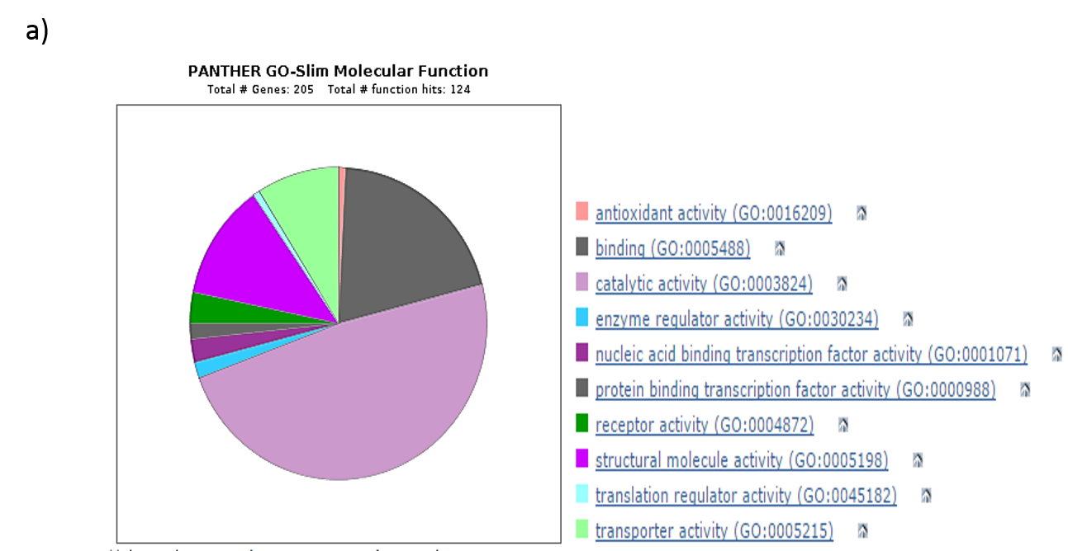

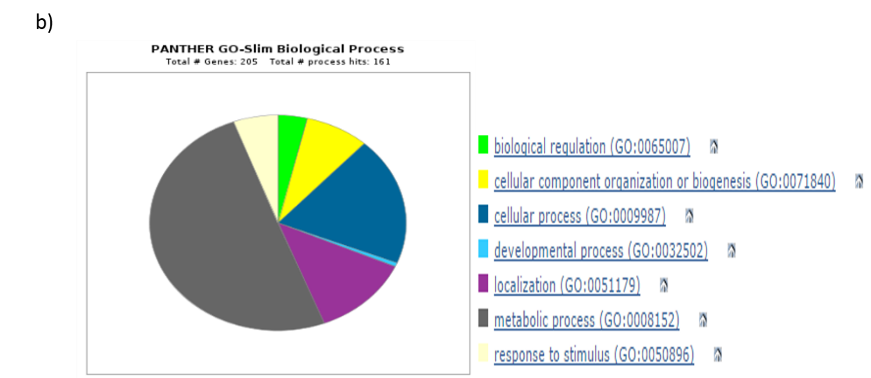

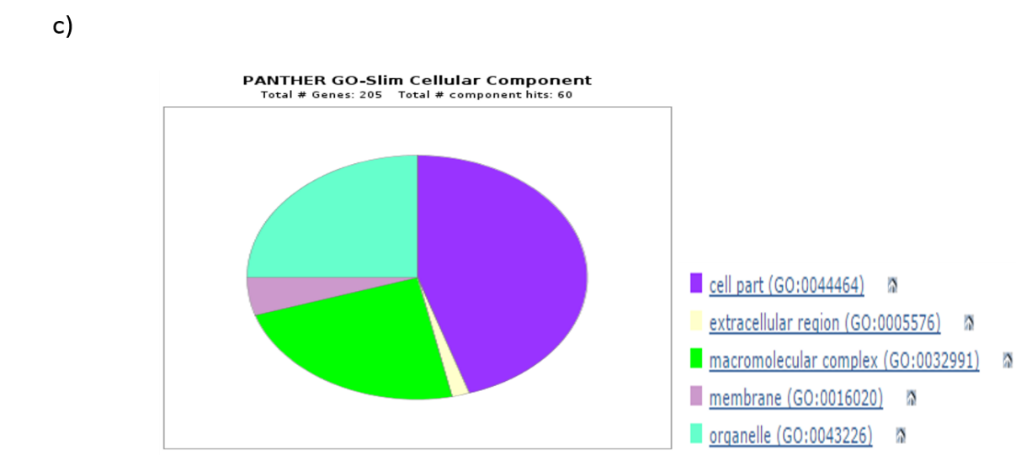

Figure 2

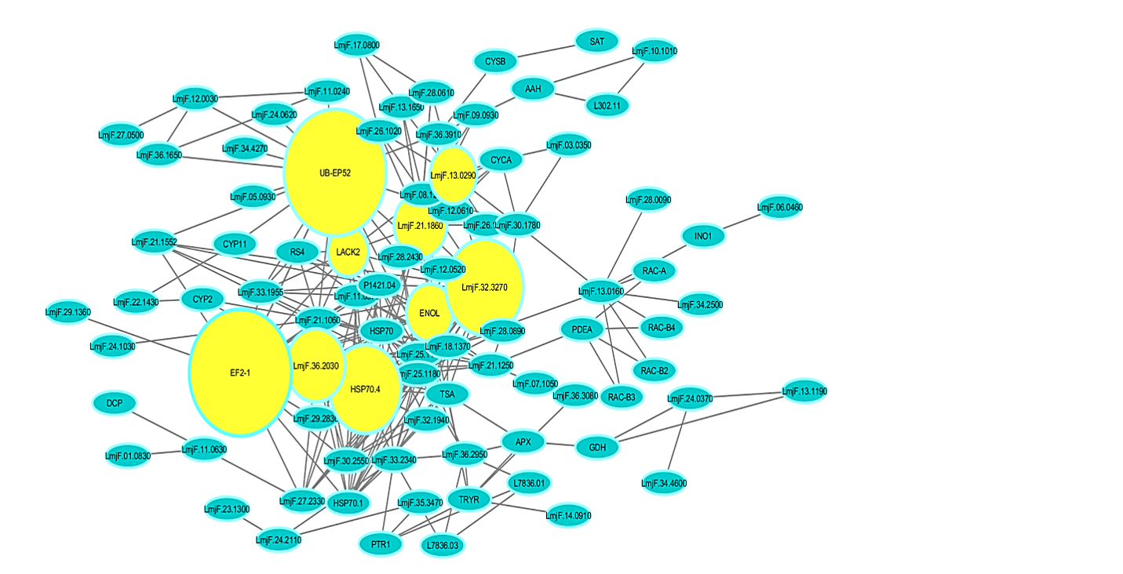

Figure 3

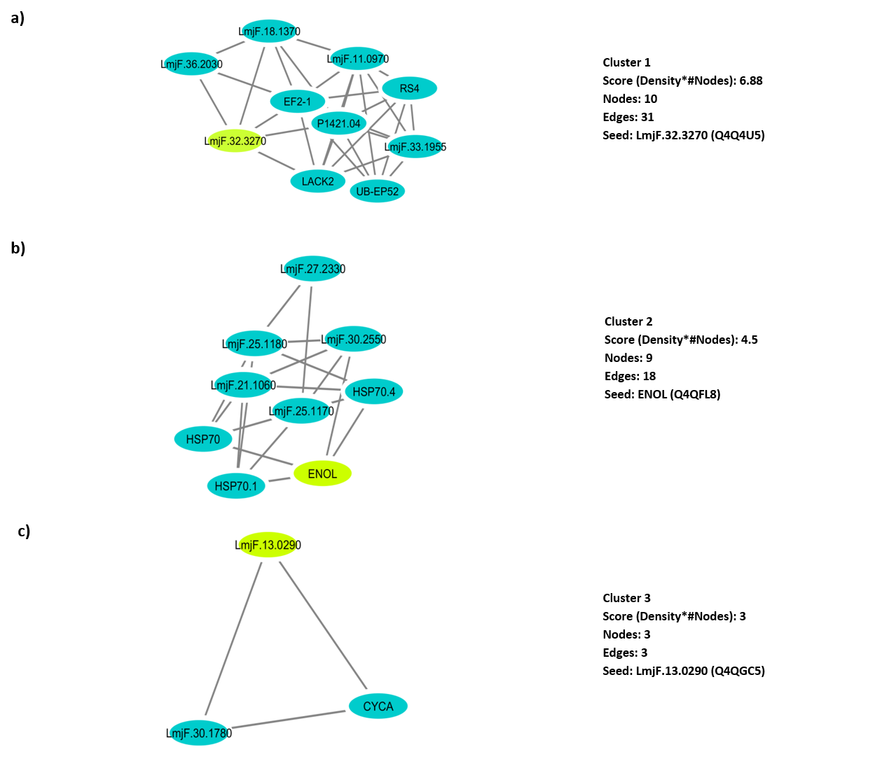

Figure 4

