**Figure 1**

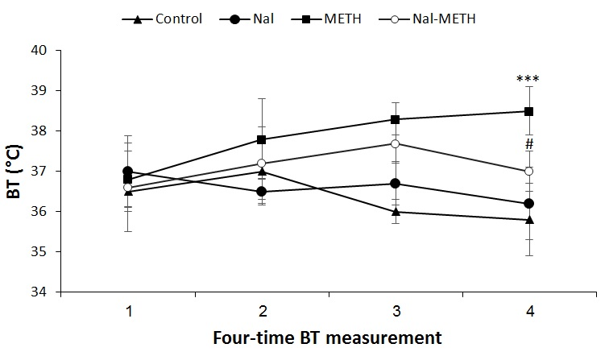

**Figure 2**

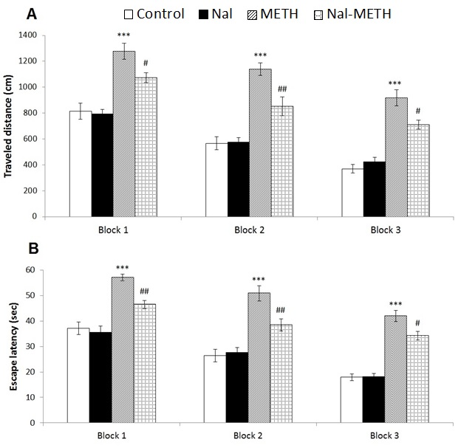

**Figure 3**

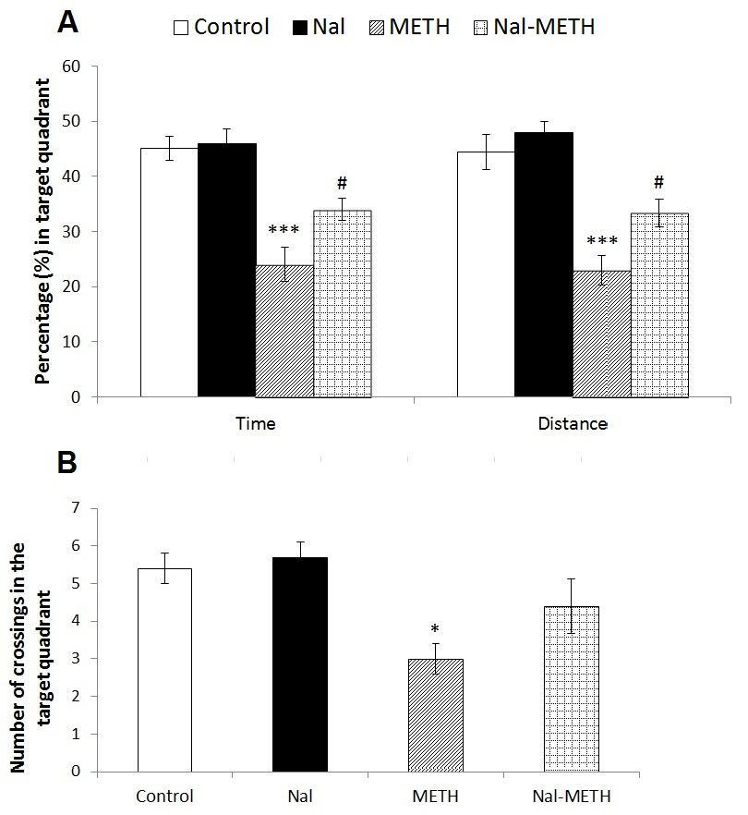

Table 1

Swimming speed and latency to find the visible platform

|  |  |  |
| --- | --- | --- |
| Groups | Swimming speed (cm/s) | Escape latency (s) |
| Control  Nal  METH  Nal-METH | 21.43 ± 1.63  22.29 ± 3.01  20.95 ± 2.61  21.70 ± 2.52 | 19.36 ± 2.34  20.12 ± 1.33  18.36 ± 3.12  17.14 ± 2.05 |

One way analysis of ANOVA revealed no any significant difference between the groups. Data are expressed as mean ± S.E.M.