Annealing (°C) | Size(bp) | Primer sequence(5’-3’) | Name
57 | 182 | F: GCTATGAGTTACTGCGTTCG  R: CTCTTTGAACTCACAGCCAG | BID
56 | 167 | F: ATTTTATTACCGTTGGCTG  R: CTGCGAGAGTTTATAGTGGA | BCL2
55 | 189 | F: GCAGGAACACTATAAAGGCG  R: CCCTTGAAGTGTCCGTGTG | GAPDH
Table1. Sequence, size and temperature of binding primers used

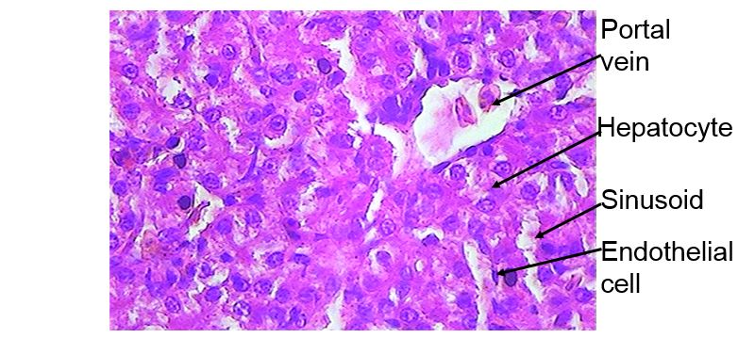
Figure1. Microscopic images of the liver (X400) in healthy control group: the rows of normal liver cells, bile ducts, sinusoids and blood vessels.
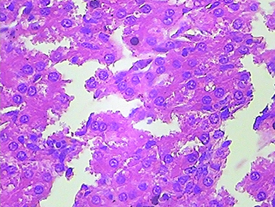
Figure2. Microscopic images of the liver (X400) in Olive leaf extract group (0.5 mg/kg): cell degradation and disintegration of the hepatocyte cell line and the destruction of sinusoids.
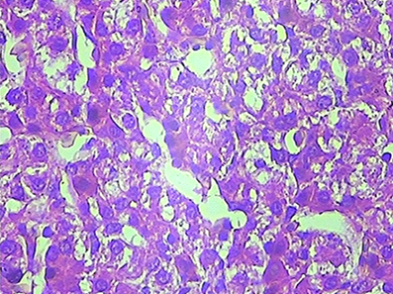
Figure3. Microscopic images of the liver (X400) in Olive leaf extract group
(1 mg/kg): a degree of destruction between the cells.
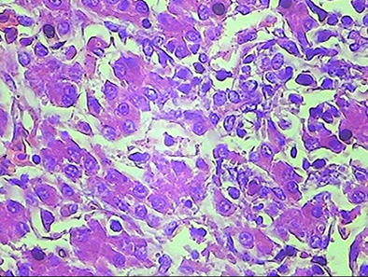
Figure4. Microscopic images of the liver (X400) in Olive leaf extract group
(1.5 mg/kg): normal cells, bile ducts and blood vessels.
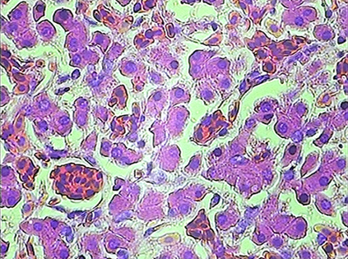
Figure5. Microscopic images of the liver (X400) in the toxic control group: the most hepatic cell dislocation, as well as the presence of cells in the bile duct and sinusoidal degeneration.

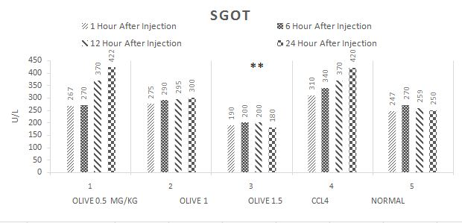

Fig. 6. The SGOT tests showed a high dose of olive leafs has been preventing the liver damage in compare with CCL4 group (P <0.05).
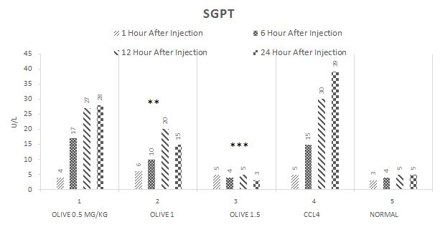
Fig.7. shows the SGPT test, olive leafs in two doses (1 and 1.5 mg/kg) can prevent the liver damage in compare with CCL4 group (P<0.05 and P<0.005).
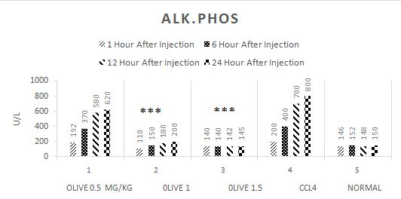
Fig. 8. The ALK.PHOS test shows olive leaf in 1 and 1.5 mg/kg dose can prevent the liver damage in compare with CCL4 group (p<0.005).
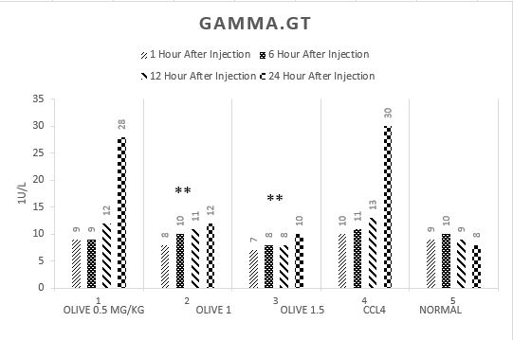
Fig.9. The GAMMA.GT test shows olive leaf in 1 and 1.5 dose can prevent the liver damage in compare with CCL4 group (p<0.05).
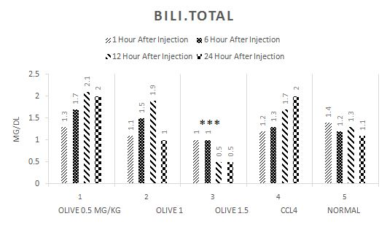
Fig.10. BILI.T test shows 1.5 mg/kg dose of olive leaf can prevent the liver damage in compare with CCL4 group (p<0.05).
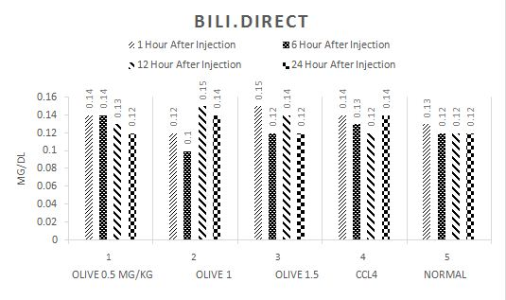
Fig.11. shows BILI.D test, there is no significant difference in compare with poison control group.

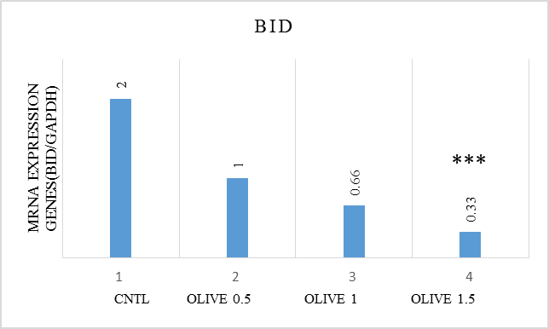
**
Fig.12. The BID expressions decrease with increasing does of olive leaf extract, in 1 and 1.5 mg/kg there are significant difference in comparison with control group (P<0.05 & P<0.005).
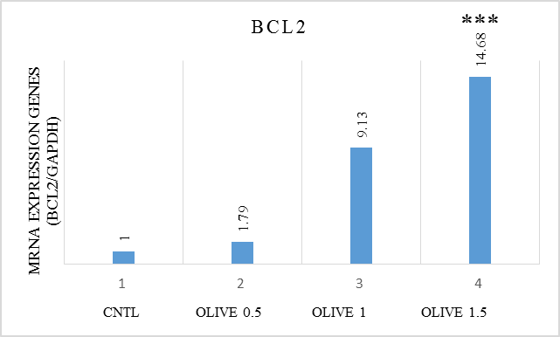
***
Fig.13. The BCL2 expressions increase with increasing does of olive leaf extract, in 1 and 1.5 mg/kg, there are significant difference in comparison with that of control group (p<0.005).

