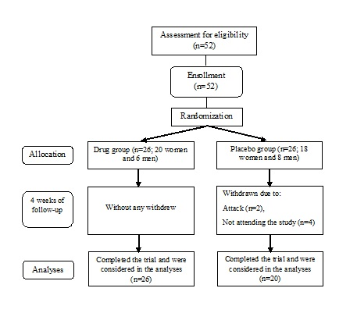

**Figure 1.** Flow diagram of the patients

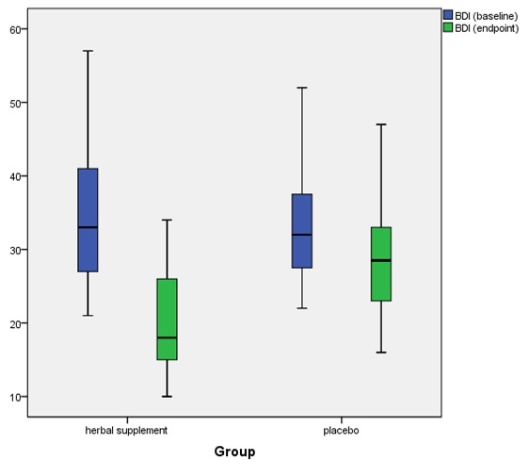

**Figure 2.** Changes in the BDI scores after an 8-week period of intervention; BDI (Beck depression inventory)