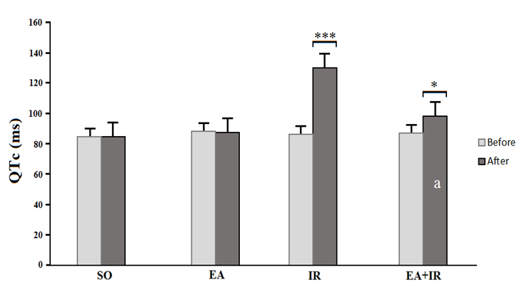

**Figure 1.** Comparison of QTc values before and after ischemia in different groups (Sham, EA,, I/R, EA+I/R) according to One-way ANOVA followed by LSD. ***=p < 0.001 and *=p < 0.05 Significant differences before and after ischemia in each group; a: Significant difference compared with IR group (p<0.01). Values are expressed as Mean ± SEM

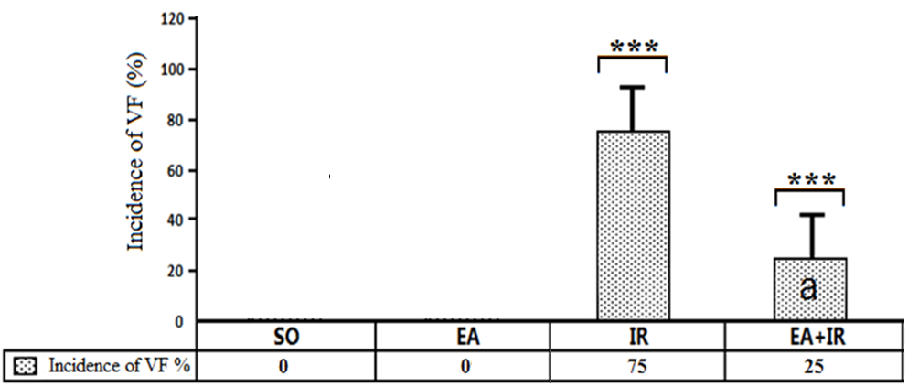

**Figure 2.** Comparison of VF incident in different groups (sham, EA, IR, EA+IR) according to the one-way ANOVA followed by LSD. ***p= < 0.0001 significant differences compared with the control groups. a: Significant reduction compared with IR group in VF incident (p < 0.001)