**Table 1.** Hub-nodes of burn PPI network are shown. D and BC refer to degree and betweenness centrality respectively.

|  |  |  |  |  |
| --- | --- | --- | --- | --- |
| **R** | **name** | **description** | **D** | **BC** |
| 1 | ALB | albumin | 502 | 0.12 |
| 2 | INS | insulin | 407 | 0.06 |
| 3 | GAPDH | glyceraldehyde-3-phosphate dehydrogenase | 359 | 0.03 |
| 4 | TP53 | tumor protein p53 | 350 | 0.04 |
| 5 | IL6 | interleukin 6 (interferon, beta 2) | 336 | 0.02 |
| 6 | AKT1 | v-akt murine thymoma viral oncogene homolog 1 | 320 | 0.03 |
| 7 | EGF | epidermal growth factor | 294 | 0.01 |
| 8 | TNF | tumor necrosis factor | 293 | 0.02 |
| 9 | VEGFA | vascular endothelial growth factor A | 289 | 0.01 |
| 10 | JUN | jun proto-oncogene | 279 | 0.02 |
| 11 | EGFR | epidermal growth factor receptor | 262 | 0.02 |
| 12 | PIK3CA | phosphatidylinositol-4,5-bisphosphate 3-kinase, catalytic subunit alpha | 262 | 0.01 |
| 13 | IL8 | interleukin 8 | 258 | 0.01 |
| 14 | FOS | FBJ murine osteosarcoma viral oncogene homolog | 241 | 0.01 |
| 15 | MYC | v-myc myelocytomatosis viral oncogene homolog (avian) | 238 | 0.01 |
| 16 | MAPK1 | mitogen-activated protein kinase 1 | 233 | 0.01 |
| 17 | MAPK3 | mitogen-activated protein kinase 3 | 231 | 0.01 |
| 18 | IGF1 | insulin-like growth factor 1 (somatomedin C) | 223 | 0.01 |
| 19 | BCL2 | B-cell CLL/lymphoma 2 | 219 | 0.01 |
| 20 | F2 | coagulation factor II (thrombin) | 215 | 0.01 |
| 21 | IL2 | interleukin 2 | 213 | 0.01 |
| 22 | IL4 | interleukin 4 | 207 | 0.01 |
| 23 | CALM1 | calmodulin 1 (phosphorylase kinase, delta) | 201 | 0.01 |
| 24 | DECR1 | 2,4-dienoyl CoA reductase 1, mitochondrial | 198 | 0.01 |
| 25 | STAT3 | signal transducer and activator of transcription 3 (acute-phase response factor) | 198 | 0.02 |
| 26 | HRAS | v-Ha-ras Harvey rat sarcoma viral oncogene homolog | 198 | 0.01 |
| 27 | ESR1 | estrogen receptor 1 | 196 | 0.01 |
| 28 | CALM2 | calmodulin 2 (phosphorylase kinase, delta) | 195 | 0.01 |
| 29 | CALM3 | calmodulin 3 (phosphorylase kinase, delta) | 190 | 0.01 |
| 30 | CASP3 | caspase 3, apoptosis-related cysteine peptidase | 185 | 0.01 |
| 31 | LEP | leptin | 179 | 0.01 |
| 32 | APP | amyloid beta (A4) precursor protein | 178 | 0.01 |
| 33 | ITGA2 | integrin, alpha 2 (CD49B, alpha 2 subunit of VLA-2 receptor) | 176 | 0.01 |
| 34 | CCND1 | cyclin D1 | 169 | 0.01 |
| 35 | CYCS | cytochrome c, somatic | 168 | 0.01 |

**Table 2.** Classified hub-nodes of burn PPI network are presented. The name of group is determined based on roles of genes in body. For example the genes of group-3 are known as cancer marker as it is mentioned in the related references.

|  |  |  |  |
| --- | --- | --- | --- |
| **R** | **Genes** | **Group name** | **Referrences** |
| 1 | ALB | albumin |  |
| 2 | INS, CYCS, DECR1, GAPDH, LEP | Metabolic and energy expenditure genes | (13-17) |
| 3 | TP53, AKT1, TNF, JUN, FOS, MYC, HRAS, PIK3CA, CCND1, ITGA2 | Cancer markers | (18-20) |
| 4 | IL2, IL4, IL6, IL8, EGF, EGFR, VEGFA, IGF, STAT3 | Interleukins and growth factors | (21, 22) |
| 5 | MAPK1, MAPK3, CALM1,CALM2, CALM3, BCL2, CASP3 | Cell function regulators | (23-26) |
| 6 | APP, F2, ESR1 | Other genes |  |

**Table 3.** Classified related pathways of burn PPI network are shown Group name was determined based on the common features pathways. For example the first group are affected by immunological events in body so are marked as Immunological related pathways.

|  |  |  |
| --- | --- | --- |
| **R** | **Pathways** | **Group name** |
| 1 | Inflammatory bowel disease (IBD), IL-17 signaling pathway, Toll-like receptor signaling pathway, Th17 cell differentiation | Immunological related pathways |
| 2 | Type II diabetes mellitus | Metabolic related pathway |
| 3 | Glioma, Colorectal cancer, Melanoma | Cancer related pathways |
| 4 | Kaposi,s sarcoma-associated herpesvirus infection, Chagas disease (American trypanosomiasis), Hepatitis B, Pertussis (bacteri) | Infection related pathways |
| 5 | Neurotropin signaling pathway | Nervous system related pathway |
| 6 | Prolactin signaling pathway | Reproduction and lactation related pathway |

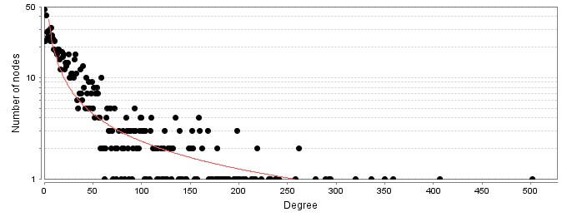

**Figure 1.** Degree distribution of nodes of burn PPI network is presented. Power law was fitted by y=axb, a=150.19, b=-0.903, R-squared=0.789, and correlation=0.683.

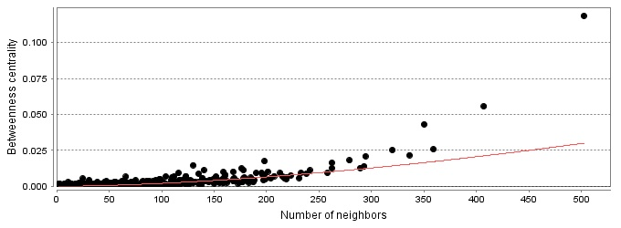

**Figure 2**. betweenness distribution of nodes of burn PPI network is illustrated. Power law was fitted by y=axb, a=000, b=1.654, R-squared=0.694, and correlation=0.841.

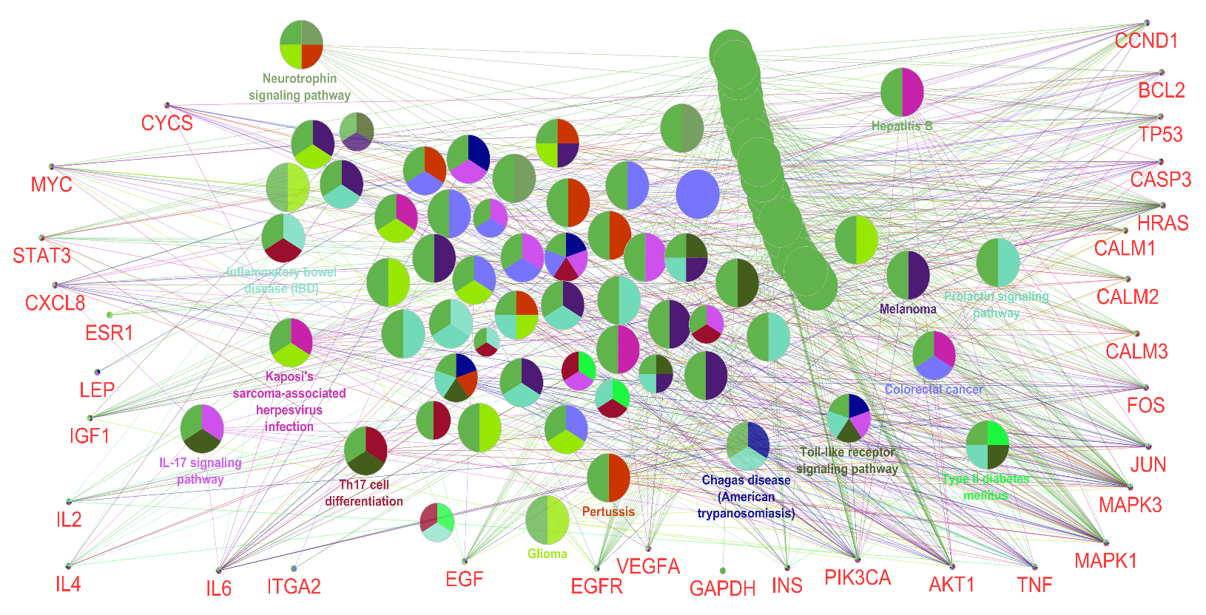

**Figure 2.** The hub-genes (that are arranged in the around of the network and are identified by red color) of burn PPI network and their related biochemical pathways (the circles) which were recognized by ClueGO are shown. The each colored part of a circle refers to a certain pathway for example the darkest red color corresponds to Th17 cell differentiation while the darkest blue color refers to Melanoma. If a circle is included the darkest red and blue colors talk about Th17 cell differentiation and Melanoma pathways. The name of circle is determined based of les P-value amount of pathways.