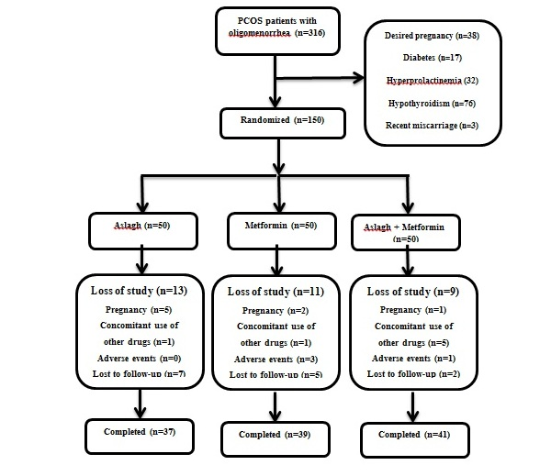

## **Figure 1. The CONSORT diagram of the study**

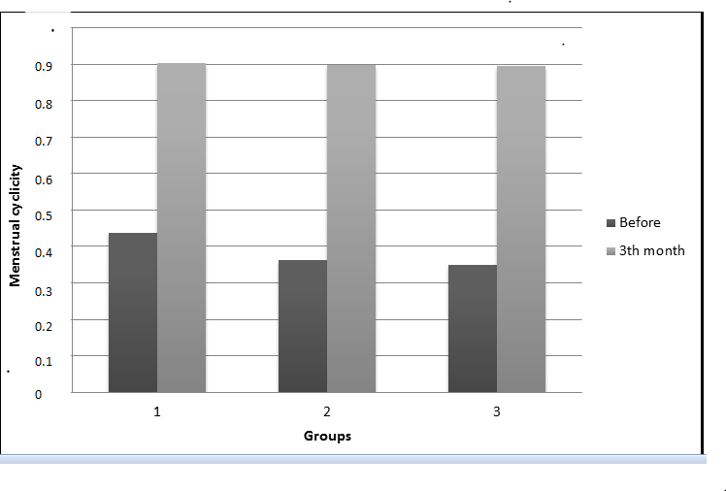

## Figure 2. Menstrual cyclicity in the third month and baseline in the three groups