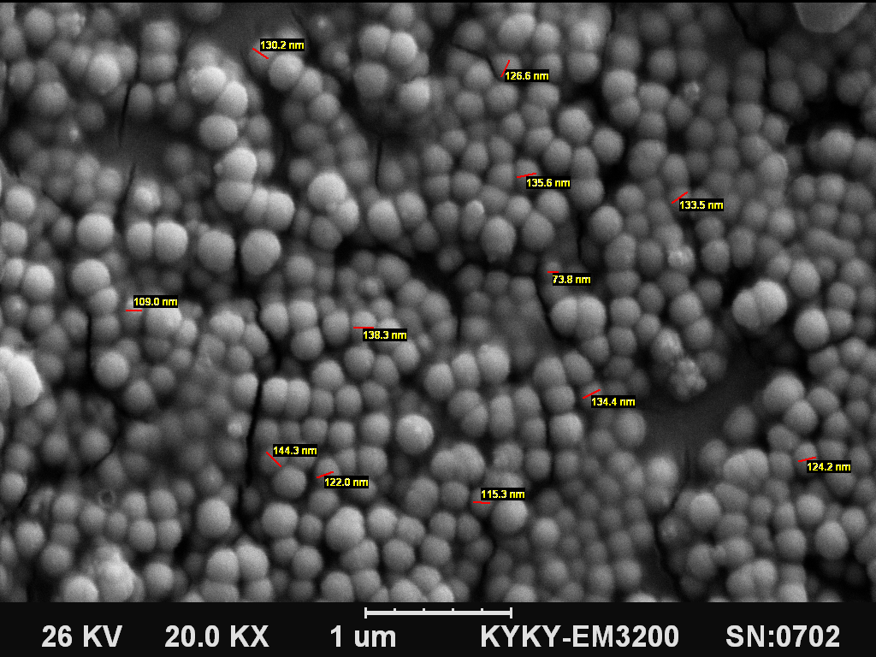

**Figure 1.** Scanninig electron microscopy of drug-loaded NPs.



**Figure 2**. Size distribution of NPs. The graph was depicted through the sizing of 136 NPs.



**Fig 3**. Drug release profile. 4 models were evaluated to obtain the best-fitted model.As R2 values indicate, the release profile is best-fitted on first-order model.



**Figure 4.** assay for investigating the cytotoxicity of NPs. NO significant cytotoxicity was observed after 24 h**.**



**Fig 5**. *In vitro* infection assay. Intracellular *B. melitensis* and *B. abortus* S19 reduction in infected J774.A1macrophage cell line after incubation for 18 h with four different formulations: drug-loaded NPs (Gen-Cs), Free gentamicin (Free Gen.), bare NPs and untreated infected cells. It should be noted that the presented data (CFU counts) shown on the graph were obtained with *B. melitensis*. However, similar data were obtained from *B. abortus.*