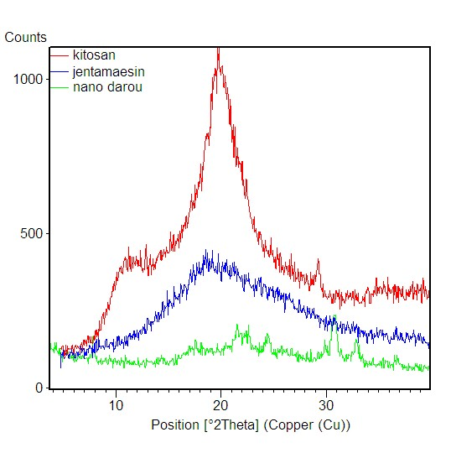

XRD- result of nanaodrug

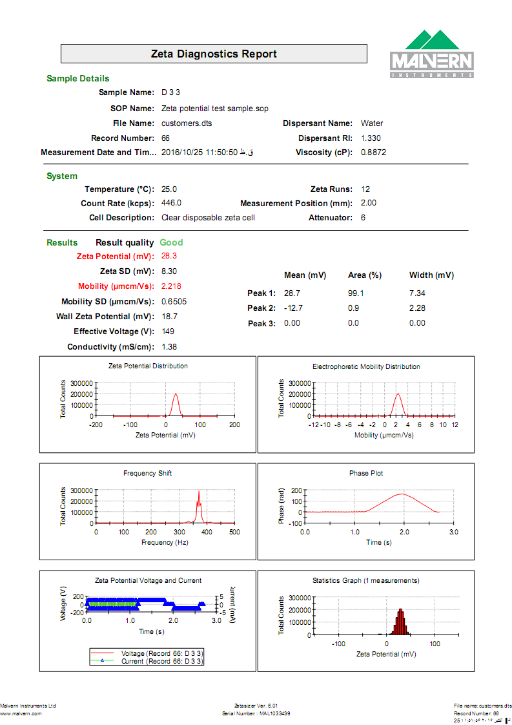

Result of zeta potential of Gen-Cs.