Dear Editor-In-Chief,

I send an original article entitled **"Effect of recombinant insulin-like growth factor 2 (IGF-II) injected into the hippocampus on memory impairment and IGF-II gene expression following hippocampal intracerebral hemorrhage in rats**" for the editorial appraisal and possible publication in Research paper. This article has not been submitted to any other journals for publication. It is acknowledged that all authors have contributed significantly and agree of with the contents of the manuscript. I declare that all authors do scientific researches by their own ideas and independently from any organization request. The protocol for the research project has been approved by Ethics Committee of Shiraz University of Medical Sciences (Ethical code: IR.SUMS.REC.1395.S767). Authors declare that they have no conflict of interest.

It consists of **3** files named "**Manuscript.**", "**Blind article.**" and "**Cover Letter.**" in word format, Times New Roman font, and printer size of 12 and “**Author statements form.**" in pdf format, and also the "**figures**" file in JPG format. The manuscript contains **13** pages including Title page, Abstract, Figure legends and References. All Figures are presented in separate files.

I am looking forward to hearing from you in this regard. Your cooperation and consideration is greatly appreciated.

Thanks in advanced and by best regards,

Asadollah Zarifkar

Department of Physiology

Shiraz University of Medical Sciences

Shiraz

Iran

Tel & Fax: +98 (71)323-020-26

E-mail: zarifkara@sums.ac.ir

**Author’s agreement:**

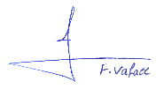Farzaneh Vafaee

8 September 2018

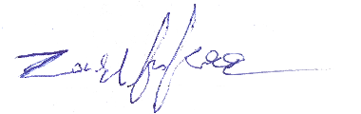Asadollah Zarifkar

8 September 2018

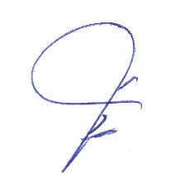[Masoumeh Emamghoreishi](https://www.sciencedirect.com/science/article/pii/S0378874104003083#!)

8 September 2018

Mohammad Reza Namavar

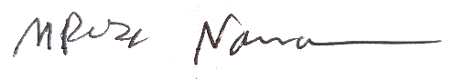8 September 2018

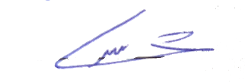Marzieh Shahpari

8 September 2018

Amir Hossein Zarifkar

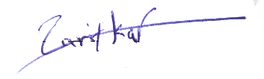8 September 2018