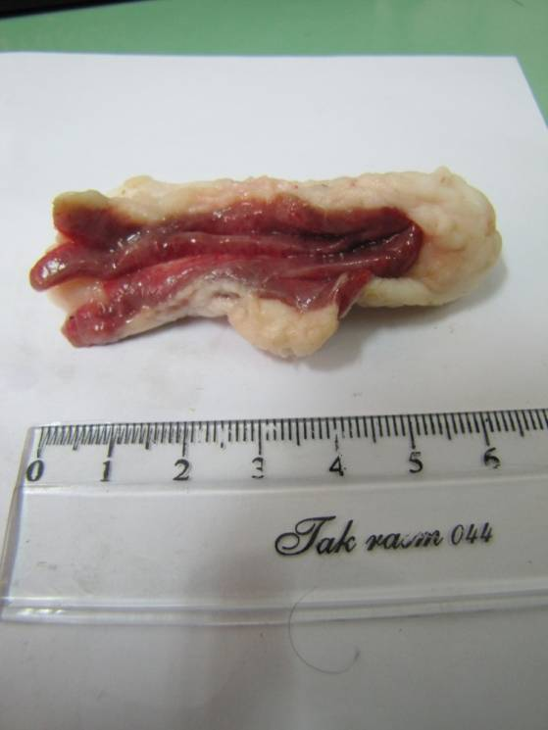

Figure 1.Hemorrhagic surface in MLN of an infected sheep

1 2 3 4

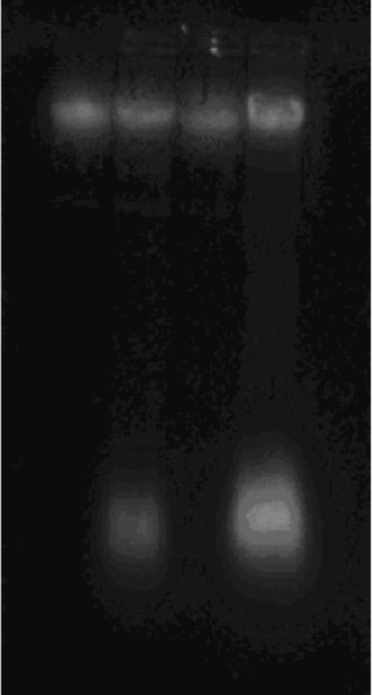

Figure 2. Agarose gel electrophoresis (0.8%) of the genomic DNA isolated by the modified extraction method used in this study. Lane 1-4: genomic DNA from four different groups.