Dear Sir or Madam,

We are very delighted to have opportunity to submit the article under the title of “Childbearing through the Lenz of Women with Minor Thalassemia:
A Qualitative Study s ”
Here with, authors who sign below guarantee that the review has not been published elsewhere and it is not being considered for publication elsewhere and it has been submitted with the full knowledge and approval of the university given as the affiliation of the authors.
Thank you so much for your kind consideration to the matter.

Authors:

1- Khadijeh Sarayloo, PhD Student
2- Khadijeh Mirzaiinajmabadi *
3- Zahra Behboodi Moghadam
4- Sharon Millen
5- Mohsen Saffari

* Associate professor, Nursing and Midwifery School, Mashhad University of Medical Sciences, Mashhad, Iran. . (*Corresponding author) +98-5138598016, Fax: +98-5138598016 E-mail: mirzaiikh@mums.ac.ir

Permission from the Ethics Committee of Mashhad University of Medical Sciences: (IR.MUMS.REC.1396.6)

Conflict of Interest: The authors report no conflicts of interest
The authors agreed with submitting the manuscript by the corresponding author and state that the corresponding author has the right to communicate on their behalf in all correspondences regarding the submitted manuscript:

 | Authors Name | signature
1 | Khadijeh Sarayloo | 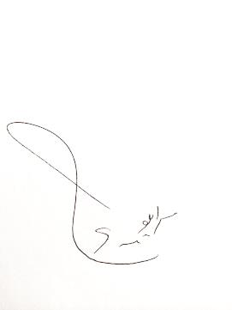
2 | Khadijeh Mirzaiinajmabadi | 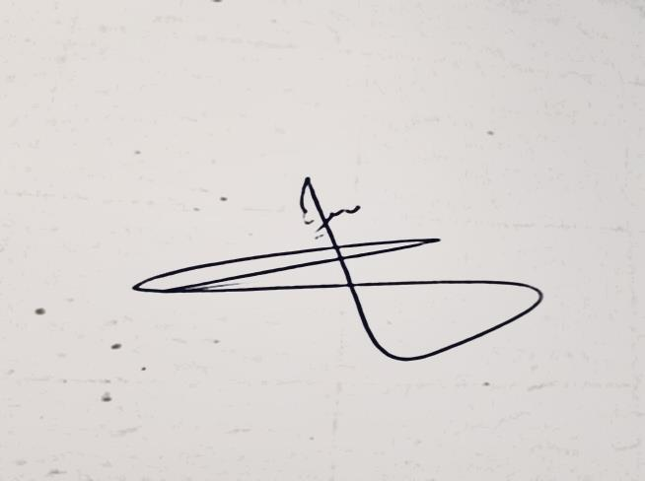
3 | Sharon Millen | 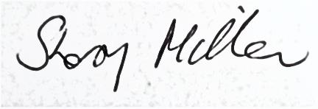
4 | Mohsen Saffari | 