Dear Editor

Hello  
We are sending you the manuscript entitled ‘‘In vitro spermatogenesis by three-dimensional culture of spermatogonial stem cells on decellularized testicular matrix” for consideration for publication in your journal, (*Galen Medical Journal*).

We believe that this manuscript is important because it is the first study about human spermatogenesis on three dimensional scaffold of decellular testis. Differentiation of human spermatogonial stem cells prepares the suitable conditions for further study of the spermatogenesis process in the in vitro and contributes to the maintenance and treatment of male infertility.  
This study has not been duplicate publication or submission elsewhere. This is an original article which has been supported by Tehran University of Medical Sciences part of a Ph.D. student thesis. The authors declare that they have no conflict of interest to the publication of this article. The project was approved by Ethics Committee of Tehran University of Medical Sciences (IR.TUMS.REC1394.1751) and all procedures were performed in accordance with the university’s guidelines.   
I look forward to hearing from you at your earliest convenience.  
Thanks for your evaluation.  
Best Regards,  
Dr. Mehdi Abbasi

Agreement for the submission of a manuscript by the corresponding author

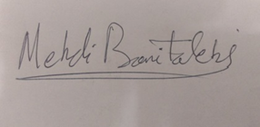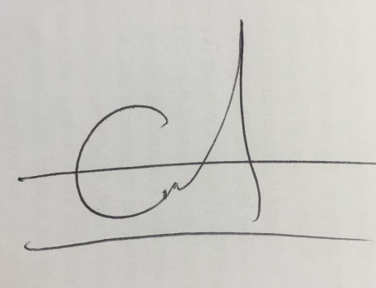 

Dr.Sepideh Ashouri Movassagh Dr. Mehdi Banitalebi Dehkordi Dr. Morteza Koruji