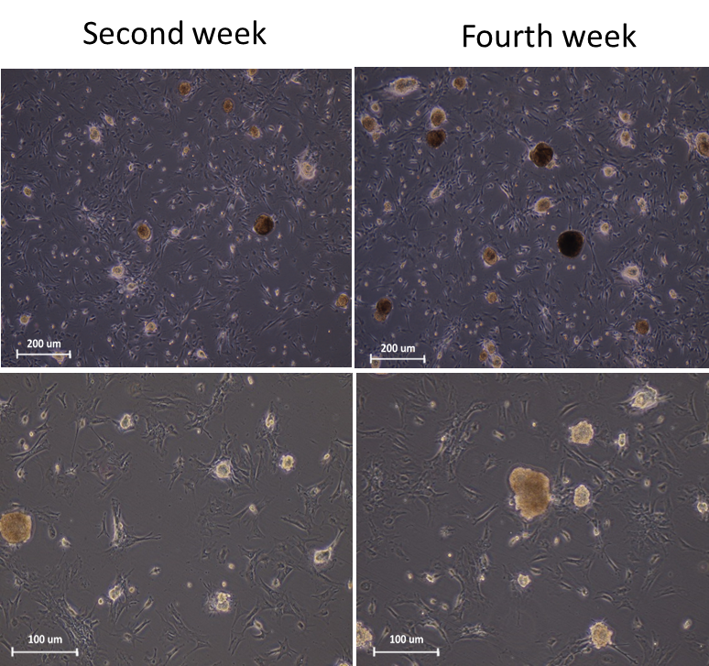

**Figure 1.** Microscopic morphology of SSCs colonies cultured in gelatin coated plate at the end of the second and fourth week. The sizes, diameter and number of SSCs colonies increased after fourth week (A). Scale bars =200 μm and 100 μm.

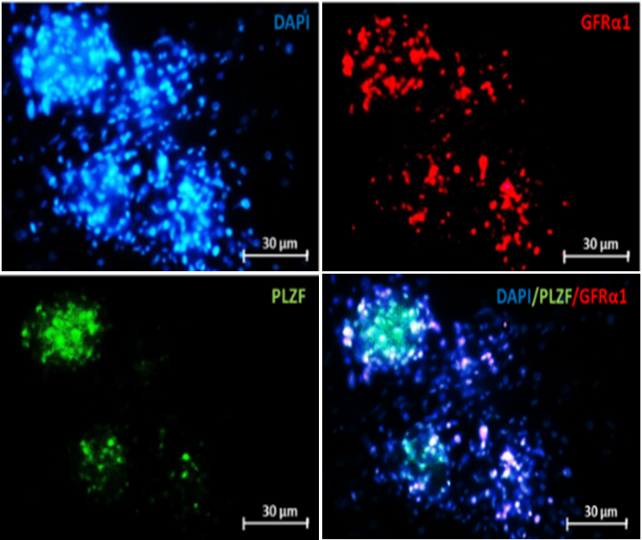

**Figure 2.** Immunocytochemistry staining of the colonies were derived from SSCs proliferation to evaluate the expression of spermatogonial markers (*GFRα1 & PLZF*) with their specific antibodies. Scale bars =30 μm.

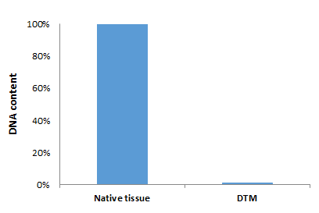

**Figure 3.** Quantification of DNA in native tissue and DTM Showed a significant decrease and almost complete loss of the DNA content in DTM. (*P* =0.001)

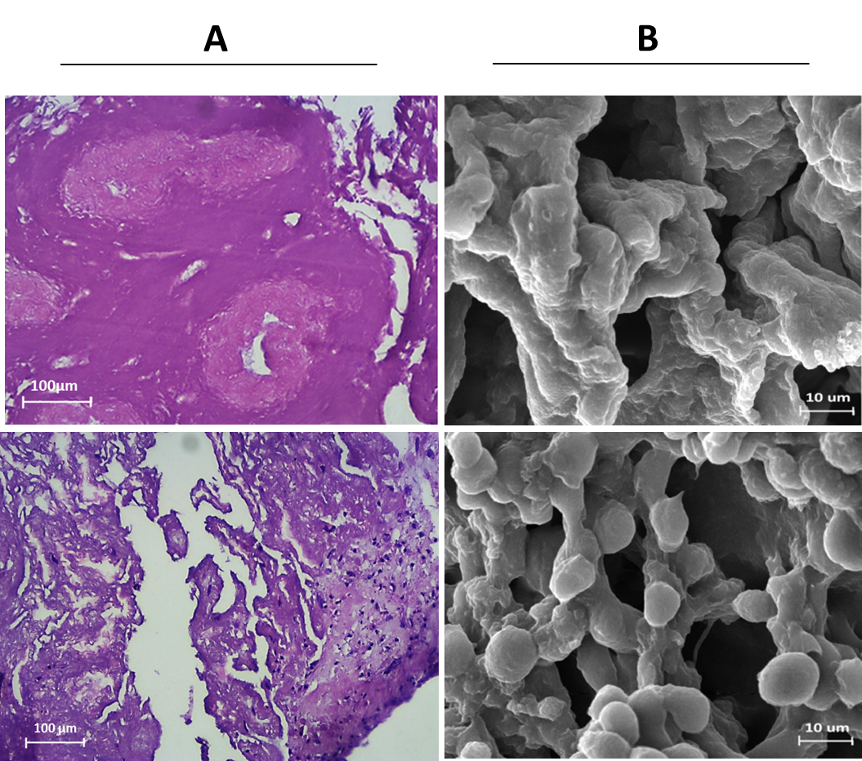

**Figure 4.** Histological staining of DTM via H and E after decellularization and recellularization (A), Scale bars =100 μm. Scaning electron microscopy for evaluation of the 3D structure of the DTM following decellularization and recellularization (B). Scale bars = 10 μm.



**Figure 5.** Expression of spermatogenesis genes )*OCT4,PLZF, SCP3, BOULE ,CREM ,Protamine2*) , in cells cultured in DTM-based 3D substrate and in a 2D substrate analyzed by real-time PCR. The results are expressed as means ± SD. *P* < 0.001.

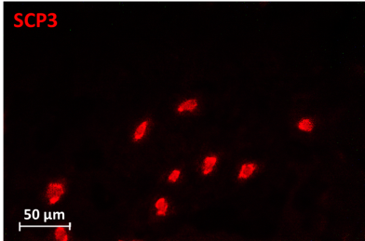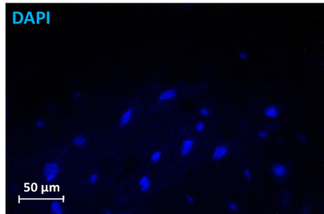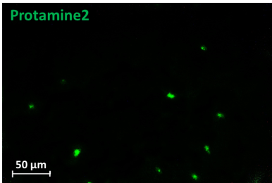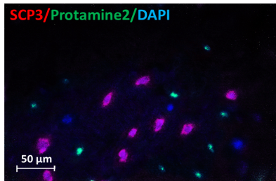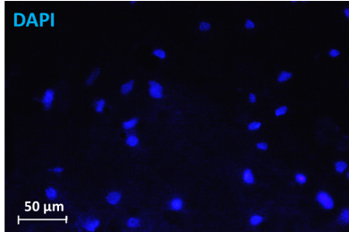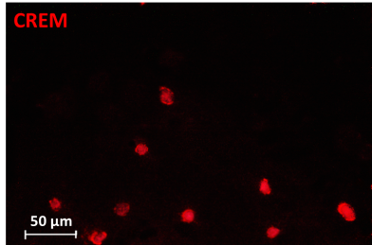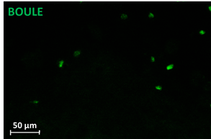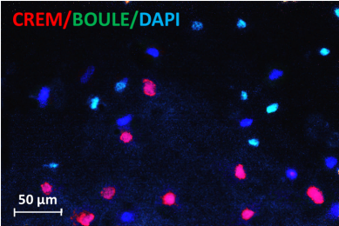

**Figure 6.** Immunocytochemistry staining was performed to evaluate the differentiation of the cells cultured on DTM for 6 weeks with spermatocyte markers (SCP3 & BOULE) and spermatid markers (CREM & Protamine2) Scale bars = 50μm.