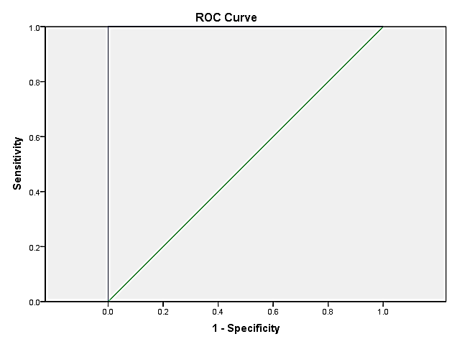

Figure1: ROC curve demonstrating the sensitivity and specificity of the LDQ in differentiating functional dyspepsia from the study population without dyspepsia.

| Cronbach's Alpha | Number of Items |
| --- | --- |
| 0.924 | 16 |

Table1: Internal consistency of total score of LDQ, demonstrating reliability of the questionnaire.

| Area | Std. Errora | Asymptotic Sig.b | Asymptotic 95% Confidence Interval | |
| --- | --- | --- | --- | --- |
| Lower Bound | Upper Bound |
| 0.993 | 0.004 | 0.000 | 0.986 | 1.000 |
| Table2: Significance of area under the ROC curve in a confidential interval of 95% (P<0.05). | | | | |

|  |  |  |  |  |  |
| --- | --- | --- | --- | --- | --- |
| Sig.  (2- tailed) | Df | t | Std.Error  Mean | Std.  Deviation | Mean |
| 0.000 | 41 | 4.141 | 0.500 | 3.241 | 2.071 |

Table 3: Paired samples test comparing the total score of the LDQ before and after receiving treatment.