**Acknowledgement**

This study was extracted from MSc thesis of Seyed Mojtaba Ojaghi which was supported by research deputy of Shiraz University of Medical Sciences. We acknowledge Mr. Saeed Heidari and Mrs. Samaneh neematollahi for the support on collecting the study data and statistical analysis.

**Conflict of interest statement**

The authors had no conflict of interest when undertaking the research.

**Ethical statement**

All subjects signed an informed consent form and the study was approved by Shiraz University of Medical Sciences research and ethics committee.

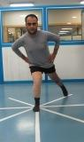

Figure1. Picture shows posteromedial reach direction of SEBT while standard elastic bandage application.

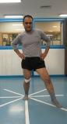

Figure2. Picture shows anteromedial reach direction of SEBT while taping application.

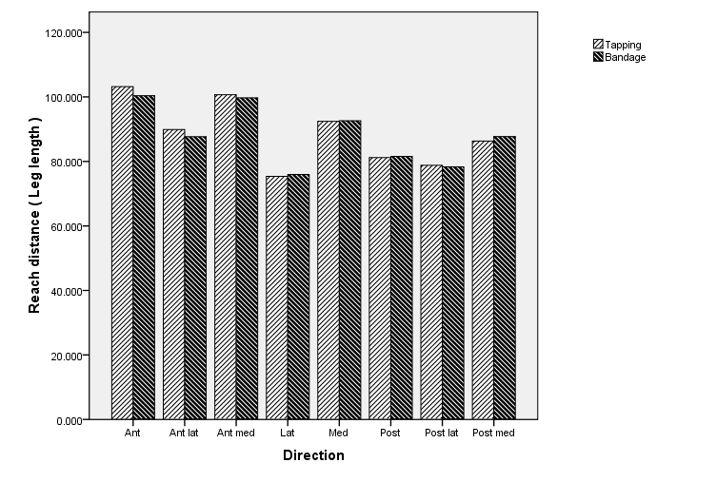

Figure3: Bar-plot shows no differences between effects of taping and bandage on SEBT.

Table 1- Normalized reach distance measures of SEBT (cm) before and after taping application

|  |  |  |  |  |  |
| --- | --- | --- | --- | --- | --- |
| Reach direction | Mean-Pre | Mean-Post | Mean differences | Standard deviation | P- value |
| Anterior  Antero-medial  Medial  Postero-medial  Posterior  Postero-lateral  Lateral  Antero-lateral | 99.95  99.2  89.53  84.35  77.25  75.91  70.24  86.62 | 103.82  101.33  93.04  87.41  81.54  79.05  74.24  89.92 | 3.876  2.142  3.506  3.059  4.282  3.142  4.00  3.302 | 6.018  5.322  7.529  6.496  5.677  6.882  7.131  5.637 | 0.017*  0.117  0.073  0.70  0.007*  0.078  0.034*  0.028* |

Table 2- Normalized reach distance measures of SEBT(cm) before and after standard bandage application

|  |  |  |  |  |  |
| --- | --- | --- | --- | --- | --- |
| Reach direction | Mean-Pre | Mean-post | Mean differences | Standard deviation | P- value |
| Anterior  Antero-medial  Medial  Postero-medial  Posterior  Postero-lateral  Lateral  Antero-lateral | 98.74  97.94  88.25  81.90  76.48  75.36  73.08  86.54 | 99.82  99.06  91.99  86.61  81.22  78.10  77.09  87.66 | 1.088  1.123  3.735  4.713  4.747  2.739  4.018  1.114 | 5.524  5.630  7.072  6.810  5.826  7.582  8.169  7.318 | 0.429  0.423  0.045*  0.011*  0.004*  0.156  0.060  0.539 |

Table 3- COP velocity and displacement measures (mm, mm/s) before and after McConnell taping application

|  |  |  |  |  |  |
| --- | --- | --- | --- | --- | --- |
| COP variables | Mean-Pre | Mean-Post | Mean differences | Standard deviation | P- value |
| AP COP velocity  ML COP velocity  AP COP displacement  ML COP displacement | 73.992  60.004  57.096  44.312 | 63.947  57.584  57.425  42.658 | 10.045  2.420  -0.328  1.653 | 18.458  6.118  6.943  7.469 | 0.034  0.122  0.843  0.361 |

Table 4- COP velocity and displacement measures (mm, mm/s) before and after standard elastic bandage application

|  |  |  |  |  |  |
| --- | --- | --- | --- | --- | --- |
| COP variables | Mean-Pre | Mean-Post | Mean differences | Standard deviation | P- value |
| AP COP velocity  ML COP velocity  AP COP displacement  ML COP displacement | 63.442  56.926  31.336  25.328 | 64.270  56.313  35.437  28.275 | -0.827  0.612  -4.101  -2.946 | 13.524  8.103  8.860  7.259 | 0.810  0.766  0.084  0.125 |

Table 5- COP-COM moment arm measures (cm) before and after McConnell taping and standard elastic bandage

|  |  |  |  |  |  |
| --- | --- | --- | --- | --- | --- |
| COP-COM moment arm variables | Mean-Pre | Mean-Post | Mean differences | Standard deviation | P-value |
| AP direction  ML direction  (taping group) | 1.731  5.810 | 2.281  5.626 | 0.550  0.184 | 1.573  0.809 | 0.197  0.393 |
| AP direction  ML direction  (bandage group) | 1.020  4.843 | 1.092  4.790 | 0.718  -0.053 | 1.777  1.043 | 0.810  0.841 |