Table 1. Baseline Characteristics of accepted abstracts of ARCIMSS 13th
Variables |  | Mean ± SD or n (%)
Affiliation of presenter | SRC affiliated | 255(52.3)
Affiliation of presenter | Non-SRC affiliated | 233 (47.7)
Educational level of presenter | Undergraduate | 370 (75.8)
Educational level of presenter | Postgraduate | 118 (24.2)
Presentation statues | Presented | 321 (65.8)
Presentation statues | Non-presented | 167 (34.2)
Presentation type | Oral | 92 (18.9)
Presentation type | Poster-discussion | 47 (9.6)
Presentation type | Poster | 349 (71.5)
Study type | Observational | 318 (65.2)
Study type | Interventional | 161 (33)
Study type | Review | 9 (1.8)
Peer review scores* | Pre-congress | 127.67±11.1
Peer review scores* | During congress | 43±10.7
*the maximum acquirable score of peer review process was 200 for pre-congress and 65 for during congress.

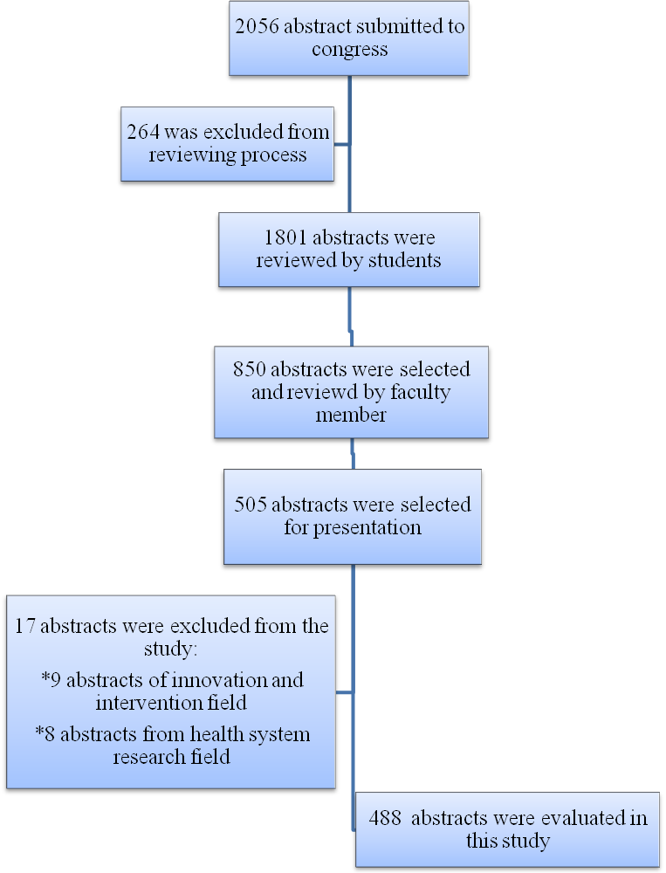
Figure 1. Flowchart of the peer reviewing in ARCIMSS 13th

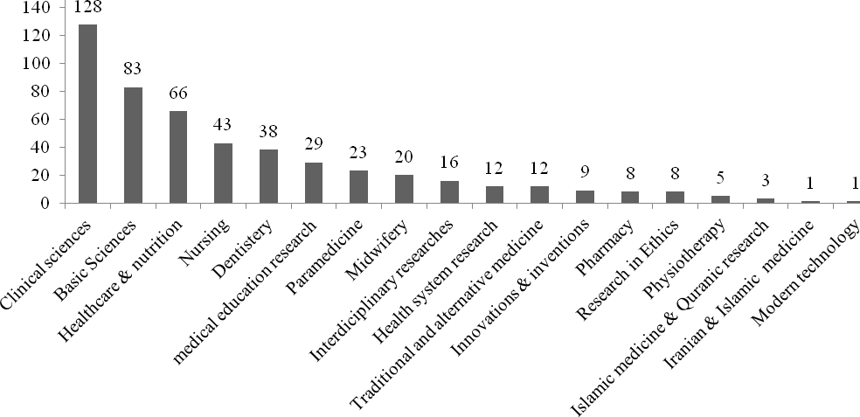
Figure 2. Distribution of accepted abstracts in each field

Table 2. The frequency of exclusion criteria in pre-congress screening stage (n=264)
Structural error* | n (%)
Non-adherence from formal structure  (Background and objective, Materials and Methods, Findings, Conclusion) | 116 (44)
Non-adherence from word count limitation | 93 (35.3)
Narrative review submission for unauthorized sections | 30 (11.5)
No findings reported | 2 (0.8)
Unconventional components  (Table, Figure, Reference, etc.) | 49 (18.7)
Others (Resubmission, Blank submission, …) | 15 (5.6)
*Each abstract may have more than one structural error.

Table 3. Distribution of different writing errors among evaluated abstracts in ARCIMSS 13th.
Punctuation error | SRC affiliated (%) |  | P value | Education level (%) |  | P value | Total (%)
Punctuation error | Yes  (n=255) | No  (n=233) | P value | Postgraduate  (n=118) | Undergraduate  (n=370) | P value | Total (%)
Authors’ name exactitude | 58 (22.7) | 72  (30.9) | 0.042 | 29 (24.6) | 101 (27.3) | 0.56 | 130 (26.6)
Non-Specified presenter | 33 (12.9) | 55  (23.6) | 0.002 | 17 (14.4) | 71 (19.2) | 0.239 | 88 (18)
Non-student presenter | 28  (11) | 55  (23.6) | <0.001 | 18 (15.3) | 65 (17.6) | 0.56 | 83 (17)
Authors’ affiliation | 141 (55.3) | 173 (74.2) | <0.001 | 81 (68.6) | 233 (63) | 0.263 | 314 (64.3)
Over 10% of word count limitation | 14  (5.5) | 24  (10.3) | 0.048 | 14 (11.9) | 24 (6.5) | 0.058 | 38 (7.8)
Key word | 2 (0.8) | 3 (1.3) | 0.673 | 0 (0) | 5 (1.4) | 0.343 | 5 (1)
Abstract with full text | 3 (1.2) | 11 (4.7) | 0.019 | 7 (5.9) | 7 (1.9) | 0.022 | 14 (2.9)
Total | 115 (45.1) | 127 (54.5) | 0.038 | 54 (45.8%) | 188 (50.8) | 0.34 | 242 (49.6)

Table 4. Mean score of peer review process in evaluated abstracts of ARCIMSS13th
Review score | SRC affiliated |  | P value | Education level |  | P value | Total
Review score | Yes  (n=255) | No  (n=233) | P value | Postgraduate  (n=118) | Undergraduate  (n=370) | P value | Total
Precongress¥  Students  Faculty  Total | 105.68±12.12  34.18±6.69  127.87±10.88 | 105.26±10.59  34.41±6.85  127.44±11.38 | 0.438  0.708  0.608 | 106.05±14.51  34.1±7.23  129.28±12.7 | 105.33±10.42  34.34±6.63  127.22±10.59 | 0.267  0.748  0.268 | 105.49±11.43  34.29±6.76  127.67±11.1
During congress#  Students  Faculty  Total | 42.66±9.76  48.83±8.5  43.87±10.25 | 40.79±12.29  45.26±8.83  41.84±11.2 | 0.318  0.086  0.097 | 40.99±11.57  44.78±9.69  42.65±10.34 | 42.1±10.86  48.1±8.06  43.1±10.81 | 0.622  0.117  0.775 | 41.8±11  46.83±8.81  43±10.7

