**Table 1:** Distribution of clinical sources of staphylococcal isolates

|  |  |  |
| --- | --- | --- |
| **Samples** | **MRSA** | **MSSA** |
| Sputum | 48 | 29 |
| Blood | 20 | 16 |
| Wound | 18 | 42 |
| Urine | 14 | 31 |
| Pus | 8 | 14 |
| ETT | 5 | 3 |
| Throat | 4 | 3 |
| Body fluid | 3 | 2 |
| Nose | 3 | 14 |
| Eye | 3 | 5 |
| Other | 3 | 6 |
| CSF | 2 | 2 |
| Axillary | 2 | 0 |
| Plural | 1 | 0 |
| Tips | 0 | 1 |
| **Total** | **168** | **134** |

*ETT = endotracheal tube, CSF = cerebrospinal fluid, TIPS = transjugular intrahepatic portosystemic

**Table 2:** Distribution of resistance phenotypes among studied MRSA and MSSA isolates

|  |  |  |  |
| --- | --- | --- | --- |
| **Phenotype** | **MRSA**  **N (%)** | **MSSA**  **N(%)** | **Significant**  **level** |
| **Constitutive MLSB** | 104 (77.6%) | 7 (4.1%) | P < 0.0001 |
| **Inducible MLSB** | 14 (10.4%) | 5 (3.0%) | P < 0.05 |
| **No resistance** | 16 (12.0%) | 151 (89.9%) | P < 0.0001 |
| **ERY-R / CLI-S** | 0 | 5 (3.0%) | NS |
| **Total** | 134 (100%) | 168 (100%) |

* ERY-R: erythromycin-resistance, CLI-R: clindamycin-resistance, NS: not significant

**Table 3:** Distribution of iMLSB phenotypes among sources of MRSA and MSSA isolates

|  |  |  |  |  |  |  |  |  |
| --- | --- | --- | --- | --- | --- | --- | --- | --- |
| **Total No.** | **CSF** | **Nose** | **TIPS** | **W** | **Sputum** | **Urine** | **Pus** | **Sample**  **Isolate** |
| 5 | 0 | 0 | 1 | 1 | 0 | 1 | 2 | **MSSA** |
| 14 | 1 | 1 | 0 | 1 | 3 | 3 | 5 | **MRSA** |

* W = wound, TIPS = transjugular intrahepatic portosystemic shunt, CSF = cerebrospinal fluid

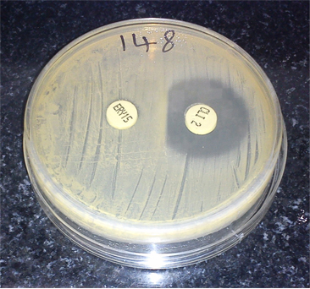

**Fig 1:** D-zone of inhibition around clindamycin disk (iMLSB Phenotype )