Dear Editor-in-Chief of Galen Medical Journal
I am enclosing herewith a manuscript entitled “Burnout and sociodemographic characteristics of nurses, Iran” for publication Galen Medical Journal for possible evaluation.
With the submission of this manuscript, I would like to undertake the responsibility that the above mentioned manuscript has not been published totally or partly, accepted for publication or under editorial review for publication elsewhere.
- Submitted manuscript is an Original Article.
The Corresponding author of this manuscript is Vahid Rashedi and contribution of the authors as mentioned below with their responsibility in the research.
- Vahid Rashedi
- Mohammad Rezaei
- Masoud Gharib
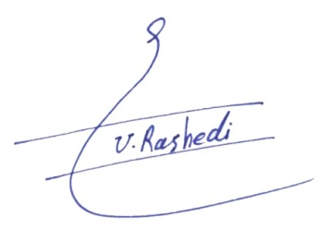

Correspondence Name Signature

