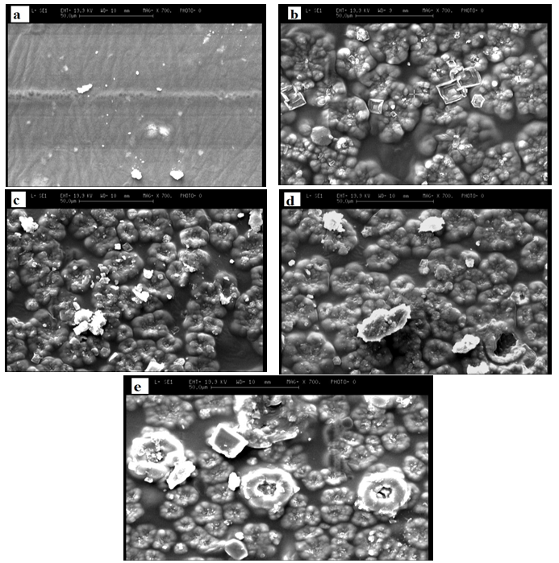
Fig. 1. Scanning electron microscopy images of pure gelatin film (a), gelatin film with 2% w/w ferula oil (b), gelatin film with 4% w/w ferula oil (c), gelatin film with 6% w/w ferula oil (d) and gelatin film with 8% w/w ferula oil (e).

