|  |  |  |  |  |  |
| --- | --- | --- | --- | --- | --- |
| White blood cells | 12650/microliter | basophils | 0.8% | MCH | 27.1 pg |
| neutrophils | 43.2% | Red blood cells | 4950000/microliter | MCHC | 35.2 gram/deciliter |
| lymphocytes | 43.3% | hemoglobin | 13.4 gram/deciliter | RDW-CV | 12.5% |
| monocytes | 11.5% | Hematocrit | 38.1% | RDW-SD | 36.8 FL |
| eosinophils | 1.2% | MCV | 77 FL | Platelet | 214000/microliter |
| MPV | 9.3 FL | PDW | 16.5 | PCT | 0.199% |
| Erythrocyte sediment rate | 27 millimeter/hour | Uric acid | 3.4 milligram/deciliter | calcium | 10.2 milligram/deciliter |
| phosphorous | 6 milligram/deciliter | AST | 36 U/L | ALT | 5 U/L |
| C-reactive protein | 2.7 |  |  |  |  |

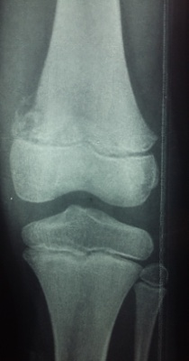

Figure 1. A lytic lesion with the periosteal reaction on the distal epiphysis of the left femur.

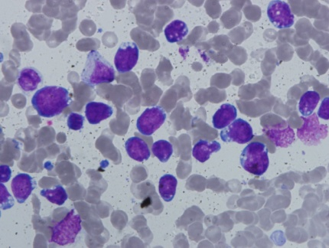

FIGURE 2. More than 90% large lymphoblasts with cytoplasmic vacuole were seen, suggestive of acute lymphoblastic leukemia