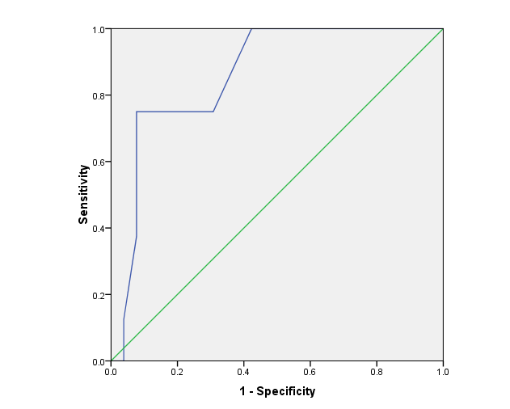

**Figure 1. The ROC curve of MELD score**

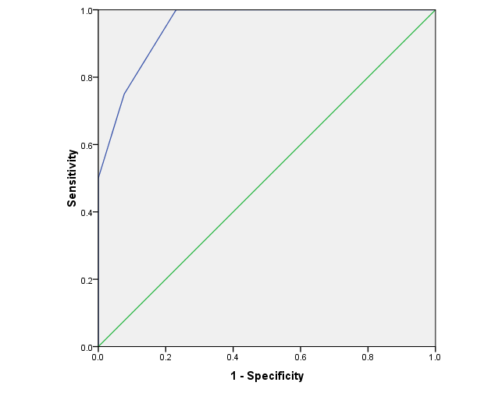

**Figure 2. The ROC Child-Pugh score**

Table 1. Child Pugh score parameters

|  |  |  |  |
| --- | --- | --- | --- |
| **Parameters** | **1 point** | **2 point** | **3 point** |
| Serum bilirubin total (mg/dL) | <34 (<2) | 34-50 (2-3) | >50(>3) |
| Serum albumin (mg/dL) | >35 | 28-35 | <28 |
| INR | <1.7 | 1.71-2.20 | >2.20 |
| Ascites | Non | Suppressed with medication | Refractory |
| Hepatic encephalopathy | Non | Suppressed with medication | Refractory |

Table 2. Clinical and biochemical characteristics, MELD and Child-Pugh between two groups of study (Gastric varice vs. esophageal varice)

|  |  |  |  |  |
| --- | --- | --- | --- | --- |
| **Parameters** | **Gastric varic** | **Esophageal varic** | **statistic** | **p-value** |
| Sex(M/F) | 8/4 | 15/7 | - | - |
| Age(year)(SD) | 60.75(19.03) | 56.59(14.18) | 0.724 | 0.47 |
| ALT (mg/dL) (SD) | 80(91.58) | 46.86(38.56) | -0.96 | 0.34 |
| AST(mg/dL) (SD) | 91.42(88.48) | 67.69(70.14) | -0.81 | 0.42 |
| Serum albumin (mg/dL) (SD) | 2.76(0.37) | 2.92(0.36) | 1.22 | 0.23 |
| Serum bilirubin (mg/dL) (SD) | 2.81(2.96) | 2.4(2.02) | -0.38 | 0.69 |
| Serum creatinine (mg/dL) (SD) | 1.39(0.86) | 1.35(1.09) | -0.36 | 0.74 |
| Prothrombin time (s) (SD) | 16.28(4.31) | 18.91(6.33) | -0.43 | 0.16 |
| INR (SD) | 1.6(0.77) | 1.91(1.05) | -1.18 | 0.24 |
| Ascites (N/M/S*) | 0/5/7 | 5/10/7 | 3.80 | 0.14 |
| Hepatic encephalopathy (N/M/S) | 5/3/4 | 15/2/5 | 2.67 | 0.31 |
| MELD score (SD) | 15.83(9.26) | 17.14(8.65) | -0.52 | 0.6 |
| CHILD score (SD) | 10.33(2.39) | 9.41(2.61) | 1.01 | 0.32 |

* N: No M: Moderate S: Severe

Table 3. Clinical and biochemical characteristics, MELD and Child-Pugh scores Pugh between two groups of study (Surviving patients vs. Deceased patients)

|  |  |  |  |  |
| --- | --- | --- | --- | --- |
| **Parameters** | **Surviving patients** | **Deceased patients** | **t** | **p-value** |
| Sex(M/F) | 16/8 | 7/3 | - | - |
| Age(year)(SD) | 57.5(16.15) | 59.4(16.04) | -0.31 | 0.76 |
| ALT (mg/dL) (SD) | 38.71(38.63) | 106.2(85.33) | -3.4 | 0.001 |
| AST(mg/dL) (SD) | 61.67(75.13) | 110.4(72.44) | -2.9 | 0.004 |
| Serum albumin (mg/dL) (SD) | 2.9(0.37) | 2.8(0.36) | 0.94 | 0.36 |
| Serum bilirubin (mg/dL) (SD) | 1.95(1.81) | 3.97(2.98) | -1.55 | 0.12 |
| Serum creatinine (mg/dL) (SD) | 1.22(1.06) | 1.73(0.79) | -3.23 | 0.001 |
| Prothrombin time (s) (SD) | 16.69(5.08) | 21.09(6.41) | -2.2 | 0.03 |
| INR(SD) | 1.53(0.72) | 2.45(1.19) | -2.4 | 0.02 |
| Ascites(N/M/S) | 5/13/6 | 0/2/8 | 8.1 | 0.01 |
| Hepatic encephalopathy(N/M/S) | 20/2/2 | 0/3/7 | 21.8 | ≤0.001 |
| MELD score(SD) | 13.71(7.71) | 23.08(7.02) | -3.19 | 0.001 |
| CHILD score(SD) | 8.67(1.99) | 12.3(1.77) | -4.99 | ≤0.001 |

* N: No M: Moderate S: Severe