**Table 1: Staging T, N and M and tumor stage in Squamous Cell Carcinoma separately for each patient**

|  |  |  |  |  |
| --- | --- | --- | --- | --- |
| Patients number | **T** | **N** | **M** | **Stage** |
|  | 3 | 1 | 0 | 3 |
|  | 3 | 0 | 0 | 3 |
|  | 3 | 0 | 0 | 3 |
|  | 3 | 0 | 0 | 3 |
|  | 3 | 0 | 0 | 3 |
|  | 3 | 0 | 0 | 3 |
|  | 3 | 0 | 0 | 3 |
|  | 3 | 0 | 0 | 3 |
|  | 3 | 0 | 0 | 3 |
|  | 3 | 1 | 0 | 3 |
|  | 4a | 0 | 0 | 4A |
|  | 1 | 0 | 0 | 1 |
|  | 3 | 0 | 0 | 3 |
|  | 3 | 0 | 0 | 3 |
|  | 3 | 2c | 0 | 4A |
|  | 3 | 0 | 0 | 3 |
|  | 3 | 0 | 0 | 3 |
|  | 4a | 1 | 0 | 4A |
|  | 2b | 0 | 0 | 2 |
|  | 2b | 0 | 0 | 2 |

**Chart 1: Activity level of thioredoxin reductase enzyme based on micromoles per minute per milliliter in tumoral and Normal tissues of patients with Squamous Cell Carcinoma**

**Table 3: Ratings of the percentage and intensity of the staining of healthy and tumoral tissues in Squamous Cell Carcinoma in immunohistochemical staining separately for each patient**

|  |  |  |  |  |  |  |
| --- | --- | --- | --- | --- | --- | --- |
| Patient | Immunohistochemical staining (based on the score) | | | | | |
| Healthy | | | Tumoral | | |
| Percentage of stained cells | Staining intensity | Total | Percentage of stained cells | Staining intensity | Total |
| 1 | 3 | 1 | 4 | 4 | 2 | 6 |
| 2 | 4 | 2 | 6 | 4 | 3 | 7 |
| 3 | 3 | 1 | 4 | 3 | 2 | 5 |
| 4 | 3 | 1 | 4 | 4 | 3 | 7 |
| 5 | 3 | 1 | 4 | 4 | 3 | 7 |
| 6 | 4 | 2 | 6 | 4 | 2 | 6 |
| 7 | 3 | 3 | 6 | 3 | 3 | 6 |
| 8 | 3 | 1 | 4 | 4 | 2 | 6 |
| 9 | 3 | 1 | 4 | 4 | 2 | 6 |
| 10 | 4 | 1 | 5 | 4 | 2 | 6 |
| 11 | 3 | 1 | 4 | 4 | 3 | 7 |
| 12 | 3 | 1 | 4 | 4 | 2 | 6 |
| 13 | 4 | 1 | 5 | 4 | 2 | 6 |
| 14 | 2 | 1 | 3 | 4 | 2 | 6 |
| 15 | 4 | 2 | 6 | 4 | 2 | 6 |
| 16 | 3 | 1 | 4 | 4 | 3 | 7 |
| 17 | 4 | 2 | 6 | 4 | 3 | 7 |
| 18 | 3 | 1 | 4 | 4 | 3 | 7 |
| 19 | 3 | 1 | 4 | 4 | 2 | 6 |
| 20 | 1 | 1 | 2 | 3 | 2 | 5 |
| Average | 3.15789 | 1.31579 | 4.47368 | 3.84211 | 2.42105 | 6.26316 |

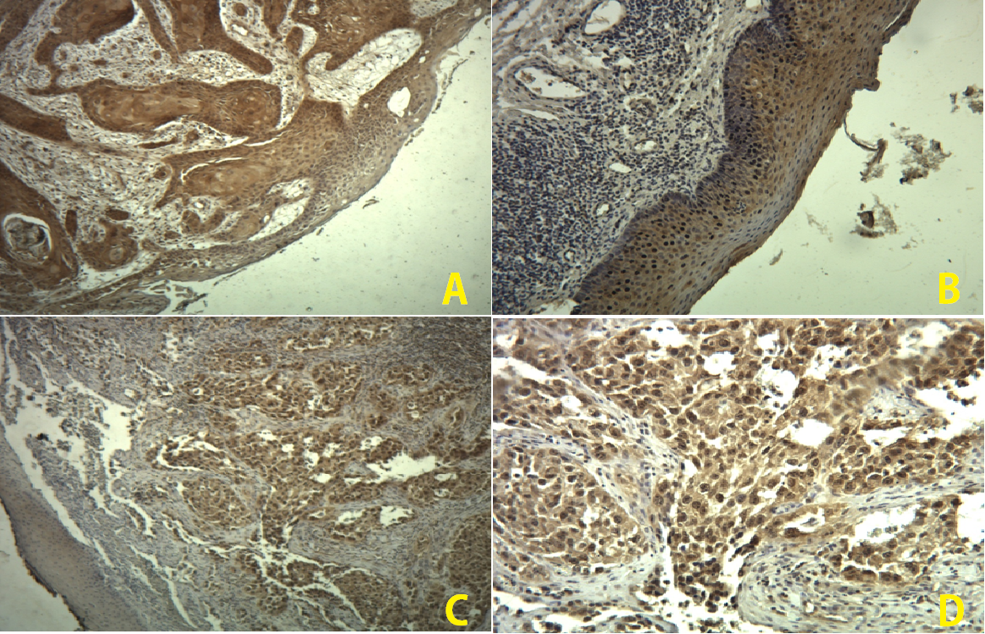

Figure 1: Immunohistochemical staining of thioredoxin in laryngeal cells. A: Tumor cells with severe staining in 95% of the cells and weak staining in 30% of non-dysplastic mucous cells. B: Normal mucosal cells with moderate staining in 50% of the cells. C: Non-tumoral mucosal cells with weak staining in 10% of the cells and tumoral cells with severe staining in 100% of the cells. D: Tumoral cells with moderate staining in 95% of the cells. (40x magnification)