**Title page:**

**Medical Ethics According to Avicenna's Stance: A Synopsis**

*Sajad Azmand1, Mojtaba Heydari2*

1- Department of Medical Ethics and Philosophy of Health, Shiraz University of Medical Sciences, Shiraz, Iran, [azmands@sums.ac.ir](mailto:azmands@sums.ac.ir)

2- Research Center for Traditional Medicine and History of Medicine, Shiraz University of Medical Sciences, Shiraz, Iran, [mheydari@sums.ac.ir](mailto:mheydari@sums.ac.ir)

Corresponding author: *Mojtaba Heydari*

Address: Shiraz University of Medical Sciences, Zand St, Shiraz, Iran.

Email: [mheydari@sums.ac.ir](mailto:mheydari@sums.ac.ir)

Tel: +989172051798

**Running title:** Medical Ethics According to Avicenna's Stance

**Page count:** 11

**Figures:** 1

**Abstract word count:** 123

**Text word count:** 2204

**Abstract:**

Medical ethics has been contemplated upon by practitioners since ancient times. Avicenna's notes on medical ethics are presented in the third chapter of the manuscript “*Fi Bayan al-hajat Ela al-Teb va al-Atteba va Vasayahom*” [meaning: “on needs to medicine and physicians and their recommendations”] by *Qutb al-Din Shirazi’s* (1236-1311 CE), one of the main commentators on Avicenna Canon of Medicine. Avicenna refers to several ethical subjects which can be expressed in three main domains: considering patient interests, communication skills, and adhering to the characteristics of professional excellence. Although there are similarities between the classical medical ethics recommendations and ethics recommendations raised by Avicenna, significant moral differences can be considered between the two views.

**Keywords:** Medical ethics, history of medicine, traditional medicine, history, ethics, conflict of interest

**Medical Ethics According to Avicenna's Stance: A Synopsis**

**Introduction:**Medical ethics has been contemplated upon by practitioners since ancient times. Chinese ancient texts on medical ethics have pointed indirectly to the four principles of modern medical ethics [1]. In ancient Iran, too, medical ethics has had its own specific position of importance [2]. It is, however, noteworthy that among all medical schools in antiquity, ancient Greece's had the most famous statements of medical ethics. The Hippocratic Oath, the most renowned text of medical ethics in the medical community, is still being used and cited all over the world [3].

Medical ethics is also paid attention to in the medical treatises of Islamic periods [4]. *"Adab-al-Tabib"* (mores of medical practice) is known as the first book on medical ethics in the era of Islam written by *Ali ibne Ishaq al-Rahavi* (9th century AD) [5]. *Hakim Seyed Mohammad Hussein Aghili Khorasani Shirazi* (18th century) has also discussed ethical issues in the medical practice in his manuscript “*Kholasat-Al-Hekmat* [6]. Rhazes (854- 925 CE), in his medical encyclopedia of *Alhavi*, discussed medical ethics in medical practice and research. Numerous exact citations to his predecessors’ works was a significant feature of Rhazes commitment to ethics in scientific writing [7]. In view of the elimination of many of ancient medical manuscripts—especially those of the Greeks—throughout history, Rhazes exact citations from previous works provided important access to the knowledge of his Greek predecessors. Even though Avicenna devoted no specific chapter of his medical encyclopedia, *Canon of Medicine*, to Medical Ethics, he has frequently mentioned the recommendations and concepts related to medical ethics in the content [8].

*Sheikh Alrais Abu Ali Husain ibn Abdallah*, known as Avicenna is one of the most famous scientists in Iran and the world history [9]. He was born in the village of *Afshane* in *Bukhara* at Samanian era (980 CE) and died in Hamadan (1037 CE) [10, 11]. He has authored 450 books in many various fields such as medicine, philosophy, physics, music, mathematics etc., of which 240 are available today [12]. One hundred and fifty books are devoted to philosophy and forty to medicine. “*Canon of medicine*” [meaning: “rules of medicine”] and *Shifa* [meaning: “healing”] on philosophy are his most famous books [13].

*Qutb al-Din Shirazi’s* (1236-1311 CE) [4], one of the main commentators on Avicenna Canon of Medicine (Figure 1), wrote multiple chapters on great medical scholar recommendations to physicians in his book “*Fi Bayan al-hajat Ela al-Teb va al-Atteba va Vasayahom*” [meaning: “on needs to medicine and physicians and their recommendations”] [14]. One of these chapters is on Avicenna’s recommendations.

These recommendations mainly contain topics which today are referred to as medical ethics. Given the extreme importance of Avicenna’s views on the history of science, we have aimed at discussing these recommendations as “medical ethics from Avicenna’s stance“ in this present article of ours.

**Methods:**In this study, an overview of "Avicenna’s medical recommendations" in the third chapter of the pistle “*Fi Bayan al-hajat Ela al-Teb va al-Atteba va Vasayahom*” [14] was conducted. Medical ethical issues raised in these recommendations were extracted and analyzed in three main aspects (Patient’s interests, Communication Skills, Adherence to professional excellence). Similarities, differences and conflicts between the current theories on medical ethics and Avicenna’s viewpoints were discussed at the end.

**Result:**Avicenna, in his overall recommendations, refers to several subjects that bear similarities to new concepts of medical ethics. His recommendations can be expressed in three main domains: considering patient interests, communication skills, and adhering to the characteristics of professional excellence.

**Patient’s interests**

Adherence to the interests of the patient is one of the most important keywords in current medical ethics literature. In different parts of his recommendations, Avicenna has advised physicians to care for the patients’ interest and has highlighted this issue in differing orders.

He considered confidentiality as one of the physician duties; he explicitly states that *“the physician ought to protects the patient’s secrets and should not express patient diseases such as hemorrhoids and diseases of women except in the cases of necessity and* [*only*] *to the people who should know.”* [14]

In another section, Avicenna has discussed the physician-pharmacist relation. He considers physician’s knowledge on different drugs as a warranty for patient interest in dealing with pharmacist. He states that it is because of the physician’s ability to inhibit the fraudulent activities of a pharmacist when the pharmacist offers expensive drugs to the patients, considering his own profit without considering the potential damages. In fact, Avicenna gives priority to the patient’s interests in the relationship among patient, physician and pharmacist. In this part, Avicenna has indirectly mentioned the subject of health care provider’s conflict of interest.

Another issue repeatedly cited in the recommendation of Avicenna is consideration of the patient's interests in diagnostic and therapeutic function of the physician. According to Avicenna’s view, a physician should consider patient’s interests and conditions in all of his decisions about patient’s care. In the selection of the specific treatment, he should start with the simplest and the least aggressive treatments: he has to avoid prescribing potential harmful drugs as much as possible.

Avicenna explicitly says that choosing the treatment by the physician should be based on the patient's interest: "*He should not prescribe therapeutics unaffordable for the patient."* He believes all physician’s behaviors must be based on patient’s interests, and this not be excluded even through his examination.

One of the outstanding points of Avicenna recommendations is the strong emphasis on avoiding any action that may cause harm to the patient: *"Physicians should not recommend the use of poison, lethal drugs and abortive medications; they are not to talk about these materials except when they want to prevent harm or when it benefits the patient"*. He also states that if the physician causes any harm to the patient or happens to miss one of his interests, he should compensate.

To summarize, from the viewpoint of Avicenna, respecting patient’s interest should dominate all aspects of the physicians' relations and decisions.

**Communication Skills**

In various parts of his recommendations, Avicenna referred to the patient-physician relationship. He believes that the physician's professional behavior must be eligible for moderation, and be "*away from extremes of intimacy or arrogance; because excessive intimacy and jesting harm the dignity of the physician while arrogance or any harshness could harm the patient-physician relationship*".

He also describes in detail how to communicate with the patient, when Avicenna says:

*“… upon the visiting of a patient, the physician should sit next to him and in a way that is in front of him so that he could see his face and listen to him well. He should ask only the questions which provide necessary information for his diagnosis and treatment: the physician ought to avoid extraneous and unnecessary questions. Moreover, the physicians should avoid prolonging the time of his visit even if the patient wants his companion. The physician should limit the visiting time to the required length in compassionate and respectful manner.”*

According to Avicenna’s view, one of the duties of the physician is to increase the patient’s hope to the good prognosis of his disease, but he should condition it to the complete compliance with the physician recommendations:

*“The physician should also be calm and dignified in his behavior, associated with patience, gentleness, and tolerance; he must listen well to the patient's complaints, explain the information he needs according to the patient's understanding, and avoid using difficult words in the conversation with the patient”*.[14]

**Adherence to professional excellence**

Another feature of professional ethics that Avicenna has greatly emphasized is physician’s adherence to continuous improvement in knowledge, behavior and ethics. Today, this feature is named professional excellence. In many parts of its recommendations, Avicenna mentioned important features and stated various examples. At the beginning of his recommendations, Avicenna has explained different branches of knowledge that a physician should master in addition to his specialized knowledge. These comprise logic, anatomy, mathematics, astronomy, geometry, and music. In fact, Avicenna emphasizes the point that physicians can improve the quality of their services if they learn and apply all the information they need.

From Avicenna’s point of view, a physician should exploit every opportunity to improve his knowledge level. The physician must travel for knowledge he needs so that he might meet medical scientists; he is not to neglect the science acquisition, as well as enthusiasm for collecting books and resources that help medical diagnosis and treatment. He also has the duty to make every effort to upgrade his studies – to be serious in understanding them. He must even not be afraid of reviewing the previous knowledge: he must not consider himself protected from forgetfulness. Avicenna believes that despite the fact that the performance of the physician should be based on existing conditions and his local patients, he is obliged to have information of the global issues and affairs, and also put them to good use.

According to Avicenna, thinking in terms of the conditions and affairs of patients and planning on their therapeutic process can lead to promotion of physicians' professional excellence. Avicenna has also emphasized the presence of the physician in clinical environments to gain an experience on what he has learned from the books or on what is not mentioned in the books.

Avicenna, additionally, recommends physicians to pay enough attention to their own physical health: if they become ill, it forms a question in the minds of the people as to whether he is unable to prevent himself from disease and/or treat himself? A physician’s malady may abate the public trust in him or in the medical profession; it also reduces the dignity and position of the physician for people. With regard to the subject expressed, we can perceive that from the stand point of Avicenna, ethical and behavioral features of a physician are so important.

**Discussion:**

Many of the mentioned expected features of the physician have remained valid today in medical and professional ethics. Focusing on the patient’s interests and preventing any patient’s damage are the important goals of medical ethics reflected in principles such as respect for patient autonomy, beneficence, non-malfeasance, confidentiality and patient privacy. [15]

*Conflict of interest* in relationships among physician, patient and other health care providers is another subject that is considered by Avicenna. Conflict of interest refers to ”a set of conditions in which professional judgment concerning a primary interest (such as a patient's welfare or the validity of research) is unduly influenced by a secondary interest (such as financial gain). [16] Avicenna's emphasis on avoiding damage to patients, evoke one of the famous principles of medical ethics, *nonmaleficence*. [15]

Explanation of *communication skills* in physician-patient relationship in detail, is another strength of these recommendations. The ability to communicate well with others, especially with patients, is an important professional competency that medical students should obtain and be evaluated on in different level. Various professional organizations in the field of medicine have emphasized the importance of Communication Skills for physicians. [17, 18] Different parameters such as good communication skills and efficient relationship with patients are essential to provide good care for patients. The establishment of these types of relationship and communication skills has many benefits including the proper understanding of patient and understanding of his condition and problems, more cooperation with the physician in the process of diagnosis and treatment, reducing the stress and, in general, increased level of patient satisfaction. [19, 20].

The subject of *excellence* is another concern that is mentioned repeatedly in Avicenna's recommendations. The physician and other medical professionals should create excellence within themselves in order to upgrade skills continuously. They must attend continual educational processes in order to improve his communication skills with patients and improve the quality of care at various levels, including individual, corporate, and public level. Furthermore, discovering new relevant scientific and technological advancements and their appropriate usage are examples of adhering to professional excellence. [21]

Despite the mentioned similarities between Avicenna's and modern medical ethics recommendations, coming deeper into these recommendations reveals important differences in the philosopichal background of their recommendations. Avicenna acknowledged divine and religious rational for his recommendations. In cotrast modern medical ethics more focuses on other philosphical schools such as deontology, utilitarianism and consequentialism.

For example, having expanded on physicians’ moral personality traits, Avicenna states that these traits are subject to God's grace and attention. Or Avicenna warns the physician who prescribes harmful and deadly drugs of **divine** punishment. However, modern medical ethics has different rational and philosophical perspective on these issues. For instance, James Rachels in justification of privacy says: “*Privacy is sometimes necessary to protect people’s interests in competitive situations*.” [22] The justification of confidentiality by the consequentialist approach in the book of “principles of biomedical ethics”, is another example for the mentioned difference of philosophical perspectives. [15]

This study just focused on a text remained from Avicenna, as his recommendations to physcians, which contatins mainly the ethical recommendations. As this study has not considered other remained manuscripts from Avicenna like"Canon of Medicine" and "*Shifa*" it can be considered as an important limitation of the study. On the other hand, this is the first study which has discussed the ethical recommendations form Avicenna, who is known as the most important medical scholar from the islamic golden age.

**Conclusion:**

Medical ethical recommendation from Avicenna can be divided into three groups: interests of the patient, communication skills, and adhering to professional excellence. Despite the similarities between Avicenna's and modern recommendations, there are fundamental differences in the philosophy of ethics in these two approaches.

Contrastive analysis of new and old ideas in the field of medical ethics in addition to familiarizing medical ethics professionals with the strengths and weaknesses of old and new theories, can provide a background for developing new promoting ideas in these fields. There is, of course, further room for elucidating Avicenna’s viewpoints on medical ethics and its various ramifications. Comparative analogy also has its own prospects for more explanation.

**References:**

1. Tsai D. Ancient Chinese medical ethics and the four principles of biomedical ethics. Journal of medical ethics. 1999;25(4):315-21.

2. Yarmohammadi H, Zargaran A, Vatanpour A, Kazerooni MHB, Dalfardi B. Women’s Medical Rights in Ancient Persia. Journal of Research on History of Medicine. 2013;2(4): 153-163.

3. Kleisiaris CF, Sfakianakis C, Papathanasiou IV. Health care practices in ancient Greece: The Hippocratic ideal. J Med Ethics Hist Med. 2014; 7: 6.

4. Enjoo SA, Mosavat SH, Heydari M. Medical Ethics in Iranian Traditional Medicine, a Review of Qutb al-Din al-Shirazi’s Ethical Code. Journal of research on History of Medicine. 2014;3(3): 113-122.

5. Jafari F, Alizadeh F, Zafarghandi N. Financial relationship of physician and patient in Traditional Iranian Medicine. Daneshvar. 2012;19(96):73-80

6. Tabei SZ, Pasalar M, Kiyani M. Medical ethics in “Kholasat-Al-Hekmat”: one of the textbooks of Iranian traditional medicine. Iranian Journal of Medical Ethics and History of Medicine. 2011 Oct 15;4(5):22-30.

7. Tabatabai SM. Rhazes's views on medical ethics. Journal of Medical Ethics and History of Medicine. 2008;1(1):10.

8. Heidari AE, Keshavarz H, Sepehr MN. Review of medical ethics in Avicenna’s book Canon of Medicine. Iranian Journal of Medical Ethics and History of Medicine. 2012;5(5):66-75.

9. Zargaran A, Mehdizadeh A, Zarshenas MM, Mohagheghzadeh A. Avicenna (980–1037 AD). Journal of neurology. 2012;259(2):389-90.

10. Heydari M, Shams M, Hashempur MH, Dalfardi B, Borhani-Haghighi A. The origin of the concept of neuropathic pain in early medieval Persia (9th-12th century CE). Acta Medico-Historica Adriatica. 2015;13(Supplement 2):9-22.

11. Mosavat SH, Ghahramani L, Haghighi ER, Chaijan MR, Hashempur MH, Heydari M. Anorectal Diseases in Avicenna’s “Canon of Medicine”. Acta Medico-Historica Adriatica. 2015;13(Supplement 2):103-14.

12. Heyadri M, Hashempur MH, Ayati MH, Quintern D, Nimrouzi M, Mosavat SH. The use of Chinese herbal drugs in Islamic medicine. Journal of integrative medicine. 2015;13(6):363-7.

13. Hosseinzadeh H, Nassiri‐Asl M. Avicenna's (Ibn Sina) the canon of medicine and saffron (Crocus sativus): a review. Phytotherapy Research. 2013;27(4):475-83.

14. QA-D A-S. Fi-Bayan-el-Hajat-elal-Tebbe-val-Attebba-va-Vasayahom. Tehran: Research Institute For Islamic & Complementary Medicine; 2008.

15. Beauchamp TL CJ. Principles of biomedical ethics. sixth ed: Oxford University Press, USA; 2009.

16. Thompson DF. Understanding financial conflicts of interest. New England Journal of Medicine. 1993;329:573-.

17. Committee GMCE. Tomorrow's doctors: recommendations on undergraduate medical education: General Medical Council London; 1993.

18. Colleges AoAM. Contemporary issues in medicine: communication in medicine: Association of American Medical Colleges; 1999.

19. Maguire P, Pitceathly C. Key communication skills and how to acquire them. Bmj. 2002;325(7366):697-700.

20. Brown JB, Stewart M, Ryan BL. Outcomes of patient-provider interaction. Handbook of health communication. 2003:141-61.

21. Ho T. What does professionalism mean to the physician? The Permanente Journal. 2013;17(4):94.

22. Rachels J. Why privacy is important. Philosophy & Public Affairs. 1975:323-33.

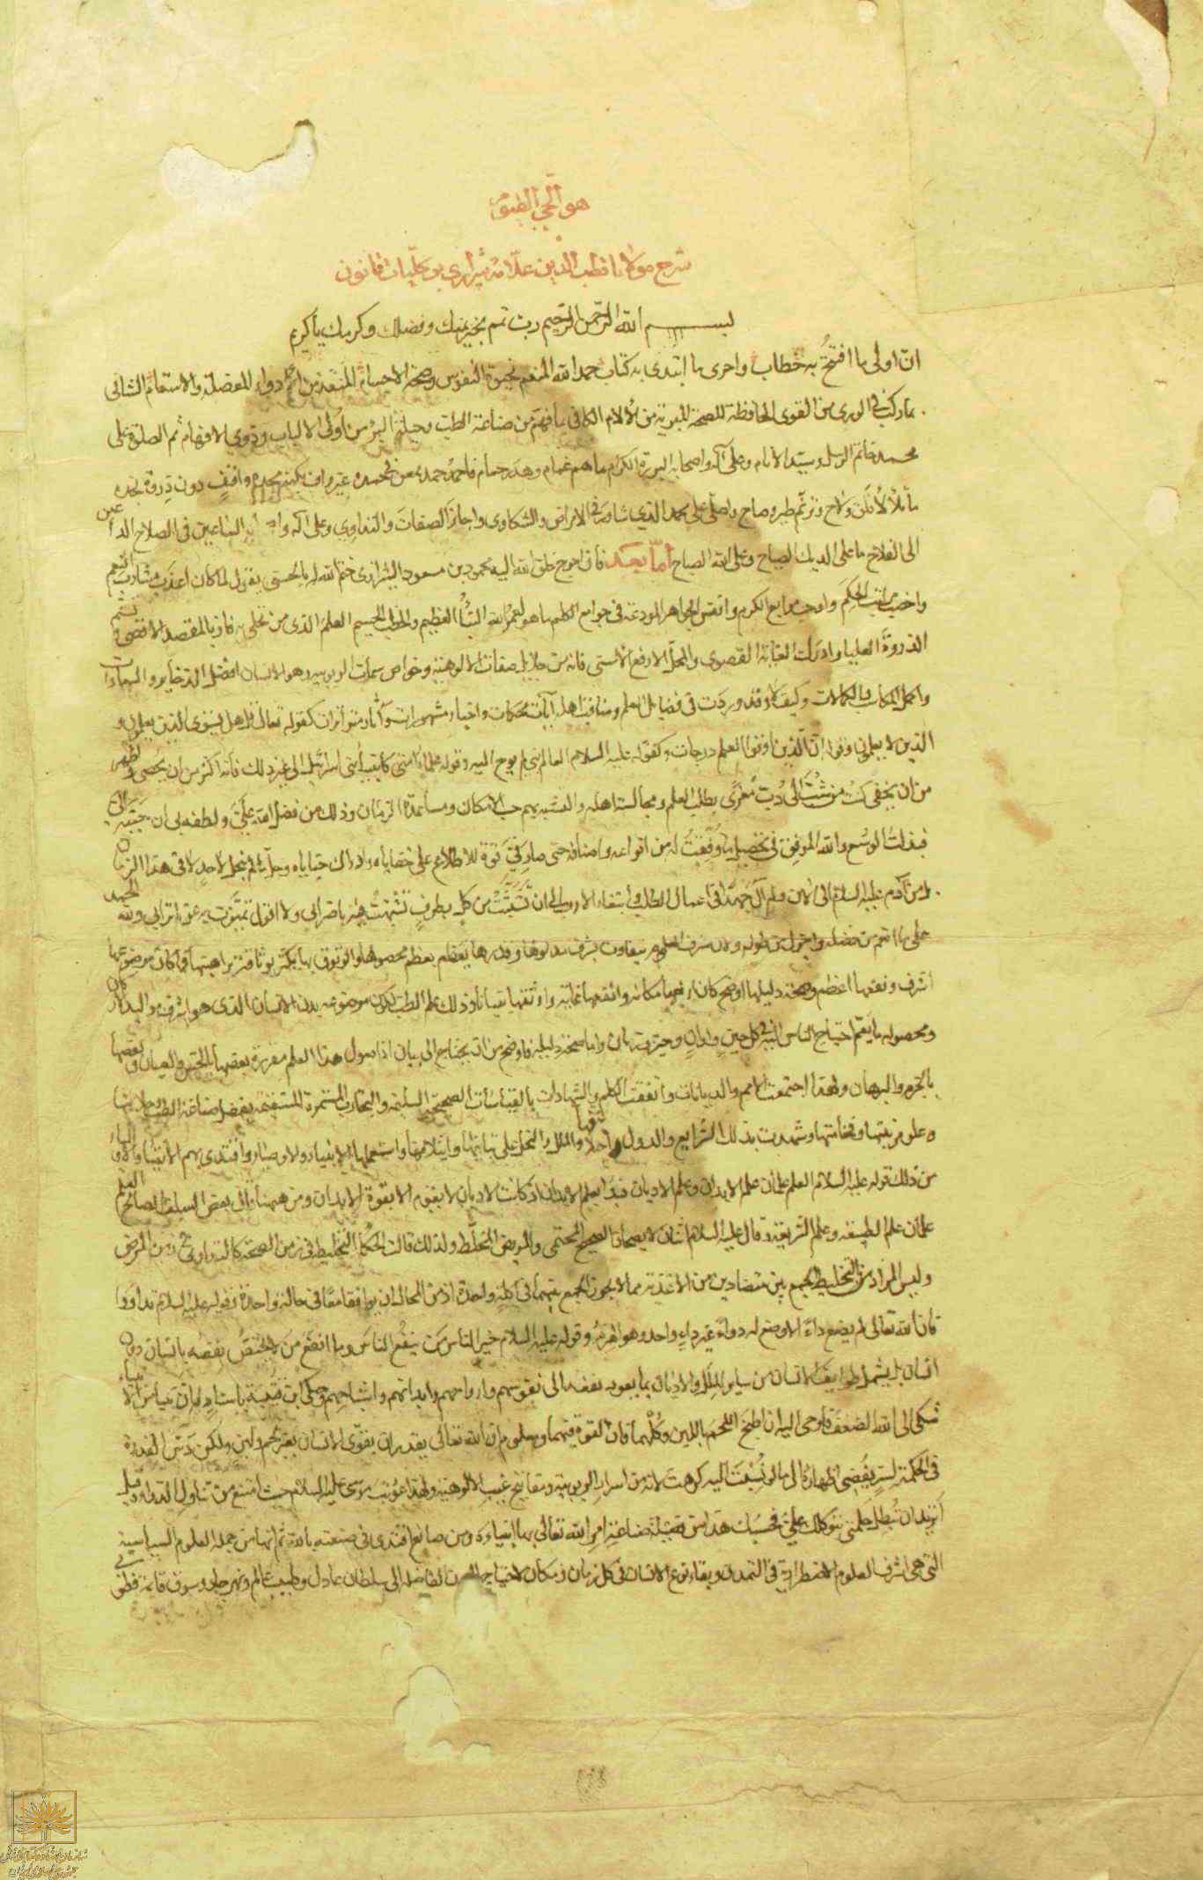Figure 1. First page of *Al-Tuhfat al-sadiyah*, a comprehensive commentary in five volumes on the Canon of Avicenna by Qutb al-Din al-Shirazi (1236-1311 CE).