**Tab1:**

Demographic characteristics of participants

|  |  |  |  |  |  |
| --- | --- | --- | --- | --- | --- |
| p*(Baseline) | Omeprazole | Placebo | A.T | Sub group | D.C |
| 0.85 | 37.8% | 37.2% | 32.7% | Male | Gender |
| 62.2% | 62.8% | 67.3% | Female |
| 0.30 | 26.7% | 13.9% | 24.5% | Single | Marital |
| 73.3% | 86.1% | 65.5% | Married |
| 0.94 | 35.6% | 27.9% | 30.6% | 18-30 | Age |
| 40% | 44.2% | 46.9% | 31-45 |
| 24.3% | 25.6% | 22.4% | 46-60 |
| 0.52 | 17.8% | 14% | 10.2% | Pre-hs diploma | Education |
| 40% | 46.5% | 34.7% | Old school diploma |
| 42.2 | 39.5% | 55.1% | Academic degree |

Abbreviations: SD: standard deviation, A.T: *Apium graveolence* and *Trachyspermum copticom*, DC: Demographic characteristics**,** *chi-square test, Significant P: <0.05

**Tab2:**

|  |  |  |  |
| --- | --- | --- | --- |
| Omeprazole | Placebo | A.T | NDI-10 (Total scale) |
| Mean ± SD | Mean ± SD | Mean ± SD |
| 22.24 ±5.92 | 21.93 ±6.87 | 23.37 ± 5.58 | Base line |
| 17.56 ±6.02 | 18.98 ±6.15 | 12.65 ±3.50 | After 4 W |
| 17.56 ±6.02 | 21.23 ±5.32 | 16.2 ±4.37 | After 8 W |

Abbreviations: SD: standard deviation, A.T: *Apium graveolence* and *Trachyspermum copticom*, W: weeks

1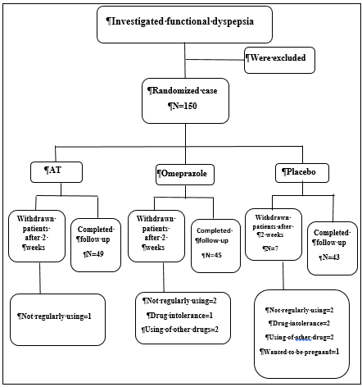

**Fig.1**

Flowchart of design and protocol of the study

**Fig.2:** Charts of study

