**Dear Editor in Chief**

Please find the manuscript entitled “The Development and Validation of Sexual Health Education Needs Assessment Questionnaire of Iranian Engaged couples”, it would be fine if you consider our manuscript for publication.

**Type of paper: Original article**

**Title:** The Development and Validation of Sexual Health Education Needs Assessment Questionnaire of Iranian Engaged couples

**Title page:**

**The title of the manuscript:**

The Development and Validation of Sexual Health Education Needs Assessment Questionnaire of Iranian Engaged couples

**Names of authors:**

1. Masoumeh Simbar

Professor, Department of Midwifery and Reproductive Health, School of Nursing and Midwifery, Reproductive

Endocrinology Research Center, Research Institute for Endocrine Sciences, Shahid Beheshti University of Medical Science, Tehran, Iran.

1. Zahra Bostani Khalesi

Assistant Professor, Department of Midwifery, School of Nursing and midwifery, Guilan University of Medical Science, Guilan, Rasht, Iran

1. Seyed Ali Azin

Assistant Professor, Reproductive Biotechnology Research Center, Avicenna Research Institute (ACECR), Tehran, Iran

**The total number of pages:** 14

**Total number of photographs:** 1

**Word counts for abstract:** 161

**Word counts for the text:** 2832

**Acknowledgment:**

This study was a part of dissertation for receiving the Ph.D. degree in Reproductive Health, Shahid Beheshti Medical Science University, Tehran, Iran. The Ethics Committee at Shahid Beheshti University of Medical Sciences approved the study

(Approval No. SBMU2.REC.1394.130).

The authors extend their thanks to all of the participants who kindly shared their experiences.

**Corresponding author:** Zahra Bostani Khalesi

Tell: +981333555056

Fax: +981333555047

Email: z_bostani@yahoo.com

Address: Shahid Beheshti School of Nursing and midwifery, Guilan, Rasht, Iran

**List of authors, including corresponding author**

|  |  |  |
| --- | --- | --- |
| **Full name of authors** | **Email address** | **Affiliation** |
| Masoumeh Simbar | msimbar@yahoo.com | Full Professor, Department of Midwifery and Reproductive Health, School of Nursing and Midwifery, Reproductive  Endocrinology Research Center, Research Institute for Endocrine Sciences, Shahid Beheshti University of Medical Science, Tehran, Iran. |
| Zahra Bostani Khalesi | z_bostani@yahoo.com | Assistant Professor , Department of Midwifery, School of Nursing and midwifery, Guilan University of Medical Science, Rasht, Iran |
| Azin Seyed Ali | ASA@gmail.com | Assistant Professor, Reproductive Biotechnology Research Center, Avicenna Research Institute, Tehran, Iran |

**Author signature Date Please print name**

1. Masoumeh Simbar

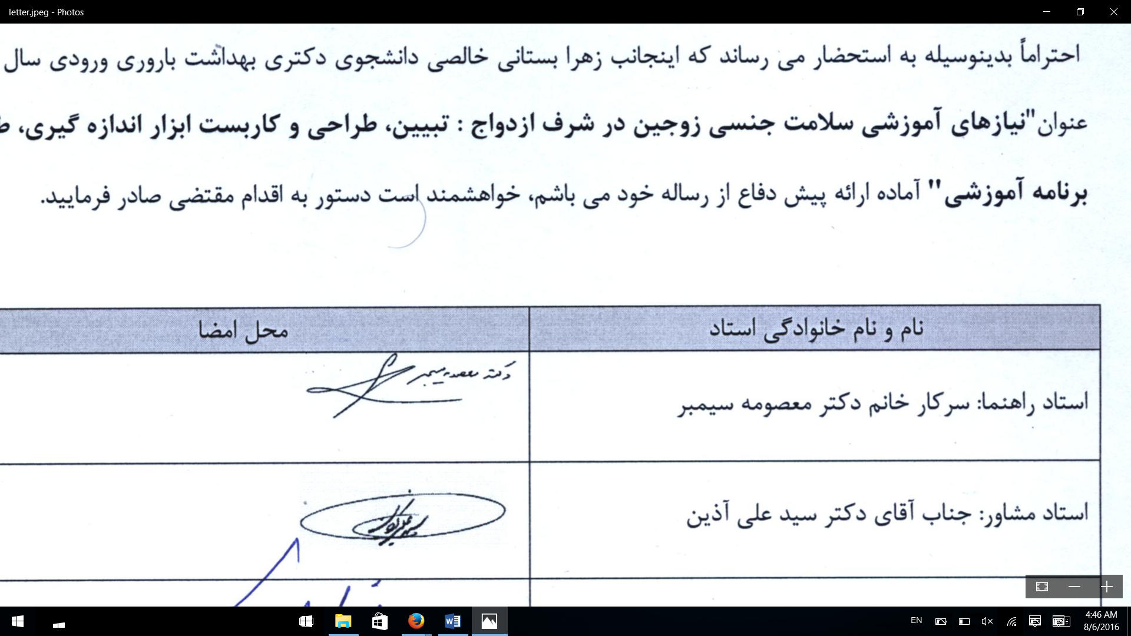

1. Zahra Bostani Khalesi



1. Azin Seyed Ali

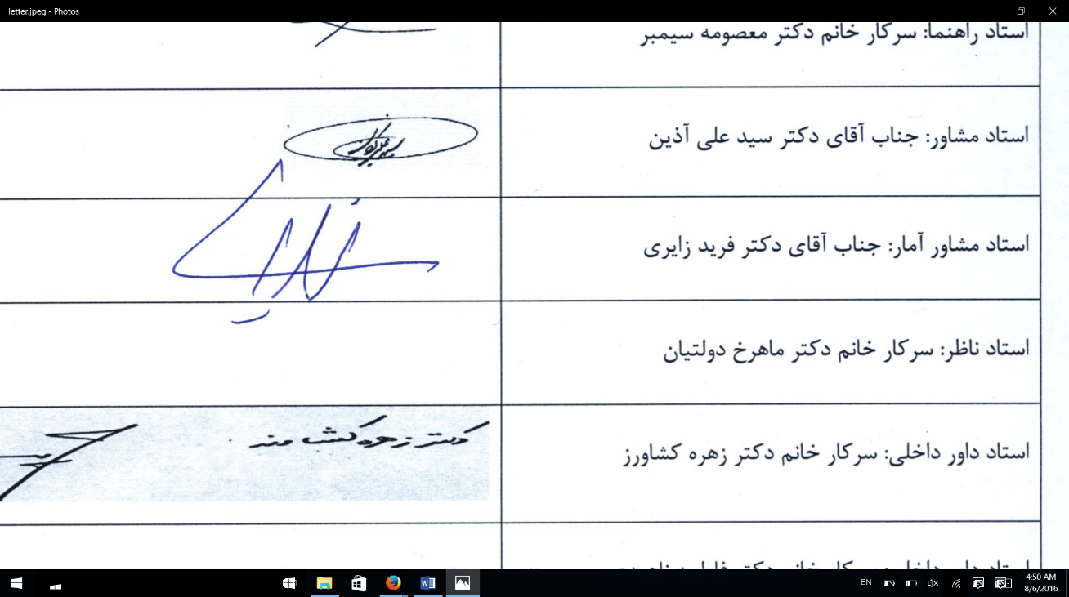

**Competing interests:**

All Author declare that the study has not been published before or is not under consideration for publication elsewhere (except as an abstract or as part of a published lecture or academic thesis); its publication is permitted by all authors and after accepted for publication it will not be submitted for publication anywhere else, in English or in any other language, without the written approval of the copyright-holder.

Financial support: The authors wish to express their appreciation to the shahid beheshti University of Medical Sciences (Tehran, Iran) for the financial support. All authors state that there is no conflict of interest in the present study.

**Authors’ Contributions**

Authors A and B designed the study, wrote the protocol, performed the interpretation of data and wrote the first draft of the manuscript. Author B and C managed the acquisition of data. Author C performed critical revision of the manuscript and managed the literature searches. Authors A and B performed analysis and administrative, technical and mate­rial support. All authors read and approved the final manuscript.

**Ethical approval**

All authors hereby declare that all experiments have been examined and approved by the appropriate ethics committee and have therefore been performed in accordance with the ethical standards laid down in the 1964 Declaration of Helsinki.

The Ethics Committee at Shahid Beheshti University of Medical Sciences approved the study

(Approval No. SBMU2.REC.1394.130).The participants were informed that they could discontinue the interviews at any time for any reason. The interviews were stopped based on participants’ willingness and emotional situation and continued when they felt it appropriate to do so. All of the interviews were performed in a private room ensure the confidentiality of the information that was provided.

**Figure1: A summary of the development and validation of SHENAQ**

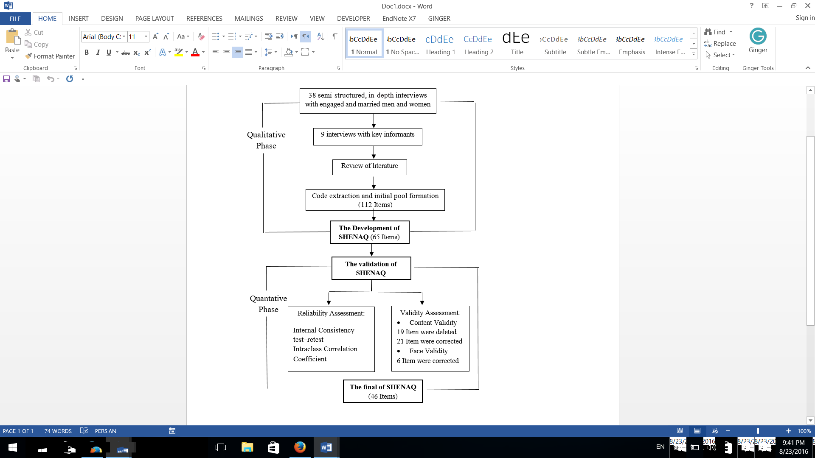

**Table 1. Demographic characteristics of participants in the in-depth interviews**

|  |  |  |  |
| --- | --- | --- | --- |
| **Variable/ Sex** | | **Male (n=15)** | **Female (n=23)** |
| Mean age (years) | | 31.3 | 28.6 |
| Education | Primary or Secondary  School Education | 2 (13.3) | 1 (4.3) |
| High School | 1 (6.7) | 3 (13) |
| High School Diploma | 4 (26.7) | 9 (39.2) |
| Above | 8 (53.3) | 10 (43.5) |
| Employment status | Householder or Unemployed | 2 (13.3) | 15 (65.2) |
| Government Employee | 8 (53.3) | 7 (30.5) |
| Self Employed | 5 (33.3) | 1 (4.3) |
| Residency | Urban | 9 (4.3) | 15 (65.2) |
| Rural | 6 (40) | 8 (34.8) |

**Table 2. Cronbach alpha coefficient and Interclass Correlation Coefficient of SHENAQ and the subscales**

|  |  |  |
| --- | --- | --- |
| **Factor** | **Cronbach's alpha coefficients** | **The intracluster correlation coefficient** |
| SHENAQ | 0.863 | 0.824 |
| Suitable content for education | 0.841 | 0.912 |
| Characteristics of competent educators | 0.724 | 0.861 |
| Appropriate technologies in education | 0.825 | 0.813 |
| Educational convenient features | 0.732 | 0.968 |

**Table 3. The SHENAQ and the subscales Scoring Range**

|  |  |
| --- | --- |
| **Subscales** | **Range of scores** |
| Suitable content for education | 21-105 |
| Characteristics of competent educators | 7-35 |
| Appropriate technologies in education | 8-40 |
| Educational convenient features | 10-50 |
| SHENAQ | 46-230 |

**Annex 1. The SHENAQ at the End of theValidityand ReliabilityAssessment**

|  |  |  |  |  |  |
| --- | --- | --- | --- | --- | --- |
| ***Statment*** | **not at all** | **a little** | **Some** | **much** | **very much** |
| **How much sexual health educational content of the following do you need?** | | | | | |
| 1. Components of the reproductive tract |  |  |  |  |  |
| 1. Performance of the sexual organs |  |  |  |  |  |
| 1. Psychological Characteristics of Men and Women |  |  |  |  |  |
| 1. Sexual myths that need to be modified |  |  |  |  |  |
| 1. Factors influencing sexual satisfaction |  |  |  |  |  |
| 1. Sexually Healthy Behaviors |  |  |  |  |  |
| 1. Ways to prevent the monotonousroutine of the sex |  |  |  |  |  |
| 1. Common sexual problems |  |  |  |  |  |
| 1. Masturbation and its complications |  |  |  |  |  |
| 1. adverse effects of smoking, alcohol and psychotropic substances on sexual performance |  |  |  |  |  |
| 1. High-risk behavior |  |  |  |  |  |
| 1. Sexually transmitted infections, symptoms and ways to prevent |  |  |  |  |  |
| 1. Family planning decision*-*making |  |  |  |  |  |
| 1. Sex skills |  |  |  |  |  |
| 1. Ability to focus on the relationship |  |  |  |  |  |
| 1. Negotiation skills between couples |  |  |  |  |  |
| 1. Commitment and responsibility in sexual life |  |  |  |  |  |
| 1. The importance of sexual health education needs assessment |  |  |  |  |  |
| 1. skills to make sexual abstinence |  |  |  |  |  |
| 1. Religious issues in sex |  |  |  |  |  |
| 1. Internet's impact and sex videos on relationships |  |  |  |  |  |
| **How much do you know the following features are essential to trainers?** | | | | | |
| 1. understand the values ​​and beliefs of participants |  |  |  |  |  |
| 1. Respect for participant |  |  |  |  |  |
| 1. Non-discrimination between participants |  |  |  |  |  |
| 1. Positive attitude to sexuality education |  |  |  |  |  |
| 1. Scientific skills |  |  |  |  |  |
| 1. Verbal skills |  |  |  |  |  |
| 1. Mutual understanding and confidence-building |  |  |  |  |  |
| **How much do you know about the proper use of the following technologies for training?** | | | | | |
| 1. 29. Valid and understandable educational resources |  |  |  |  |  |
| 1. Access to appropriate educational resources |  |  |  |  |  |
| 1. Videos |  |  |  |  |  |
| 1. Educational software |  |  |  |  |  |
| 1. Slideshow |  |  |  |  |  |
| 1. Educational assistance models |  |  |  |  |  |
| 1. Training with debate |  |  |  |  |  |
| 1. Separately training for each couple |  |  |  |  |  |
| **How much do you know proper the following spatial and temporal features for sexual health education?** | | | | | |
| 1. Comfort and sense of security |  |  |  |  |  |
| 1. Privacy and quiet |  |  |  |  |  |
| 1. Access in terms of geographical location |  |  |  |  |  |
| 1. Classrooms light |  |  |  |  |  |
| 1. Classrooms ventilation |  |  |  |  |  |
| 1. Comfortable seats with handles |  |  |  |  |  |
| 1. Less than one hour per session of training |  |  |  |  |  |
| 1. More than one session |  |  |  |  |  |
| 1. The right to choose time to attend classes for couples |  |  |  |  |  |
| 1. Continuing education after marriage |  |  |  |  |  |

I look forward to hearing you.

Thanks in advance

Dr Zahra bostani khalesi