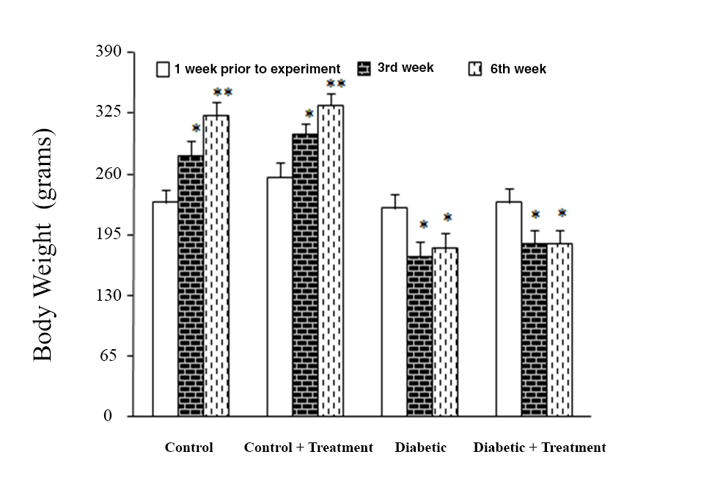

Figure 1 – Body weight changes prior to and throughout the experiment in all four study groups, \*P<0.05 \*\*P<0.01 compared to baseline of the same group

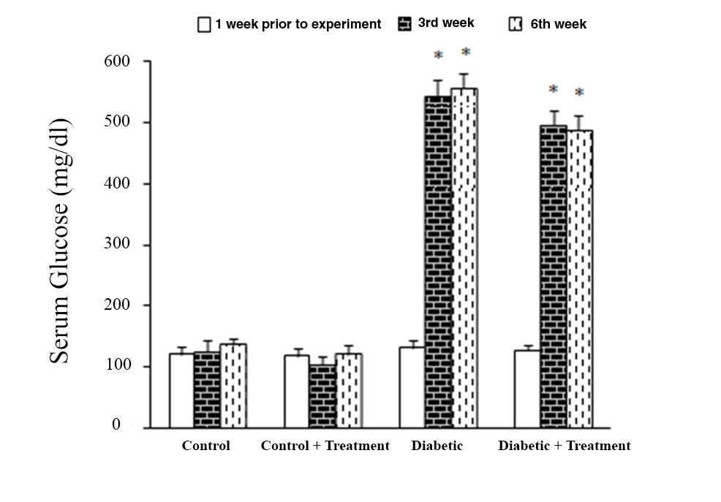

Figure 2 – Serum glucose changes prior to and throughout the experiment in all four study groups, \*P<0.001 compared to a week prior to the experiment

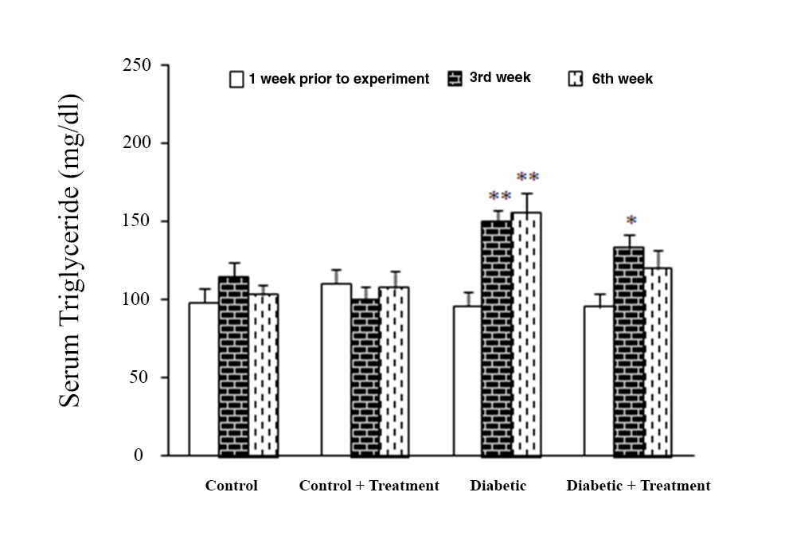

Figure 3 – Serum triglyceride changes prior to and throughout the experiment in all four study groups, \*P<0.05 \*\*P<0.01 compared to baseline of the same group

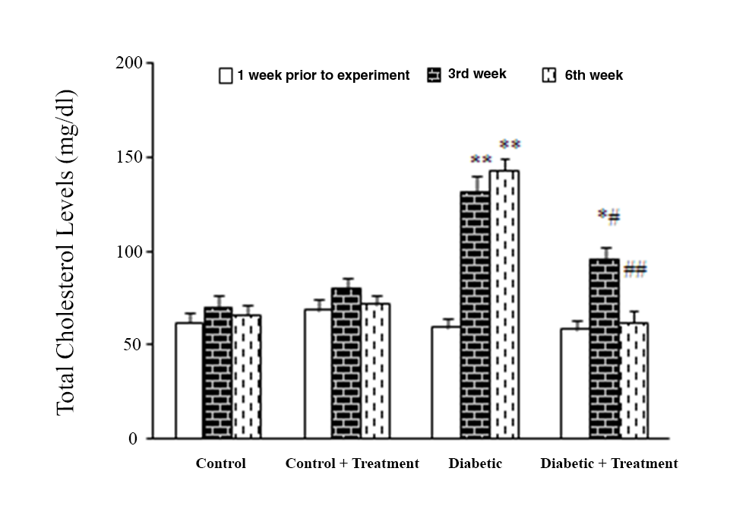

Figure 4 –Total cholesterol levels changes prior to and throughout the experiment in all four study groups, \*P<0.05 \*\*P<0.01 compared to baseline of the same group

#P<0.05, ##P<0.005 compared to diabetic group of the same week

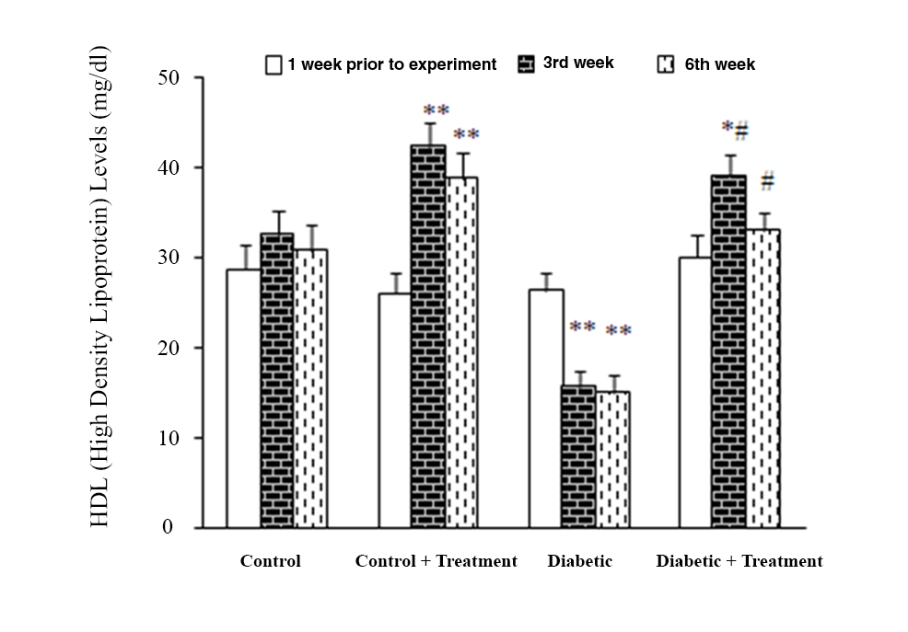

Figure 5 –HDL levels changes prior to and throughout the experiment in all four study groups, \*P<0.05 \*\*P<0.01 compared to baseline of the same group

#P<0.005, ##P<0.001 compared to diabetic group of the same week

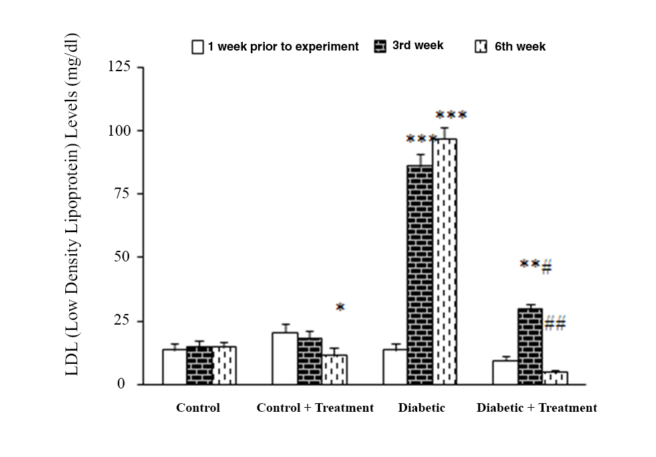

Figure 6–LDL levels changes prior to and throughout the experiment in all four study groups, \*P<0.05 \*\*P<0.01 \*\*\*P<0.005 compared to baseline of the same group

#P<0.005, ##P<0.001 compared to diabetic group of the same week

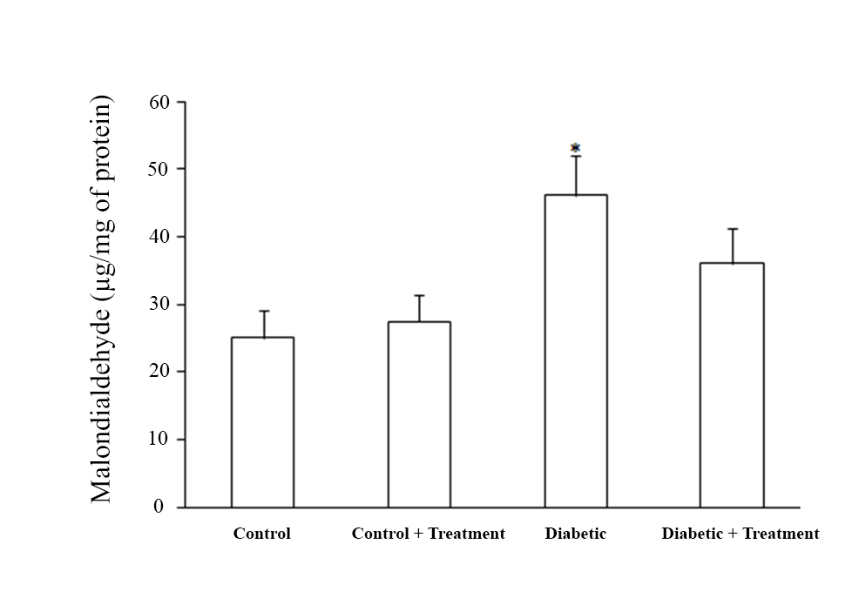

Figure 7 – Hepatic MDA levels after experiment in all four study groups, \*P<0.005 compared to control group.

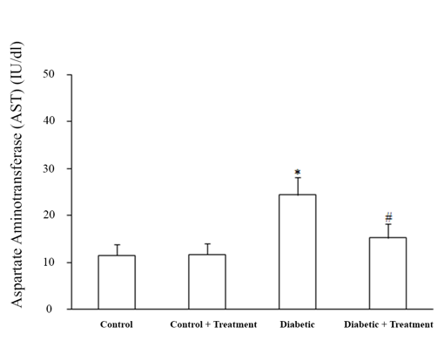

Figure 8 – Hepatic AST levels after experiment in all four study groups, \*P<0.05 #P<0.05 compared to control group.

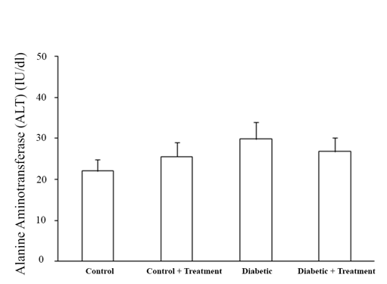

Figure 9 – Hepatic ALT levels after experiment in all four study groups