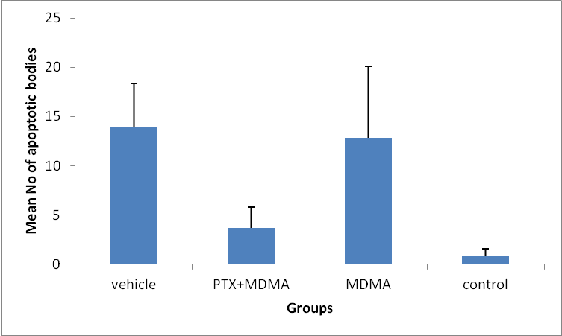

*

*

**Figure.1.** Comparison the mean no. of apoptotic bodies in vehicle, experimental (PTX+MDMA), MDMA and control groups according to TUNEL assay. * The mean no. of apoptotic bodies significantly decreased in the hippocampus of experimental group following PTX (200 mg/kg) treatment vs. MDMA and vehicle groups but there was no stastistical difference between no. of apoptotic bodies in control and experimental groups (P≤0.05). Results are the mean ± SD.

H:\ESLAH SHODE (SEPEHR)\2نتایج وسترن.jpg

Control

PTX+MDMA

MDMA

Vehicle

**Figure.2.** Effect of PTX on MDMA induced cell apoptosis. Western blotting analysis in experimental group (PTX+MDMA) indicated that the PTXtreatment could decrease the expression of caspase 3 following high dose administration of MDMA.

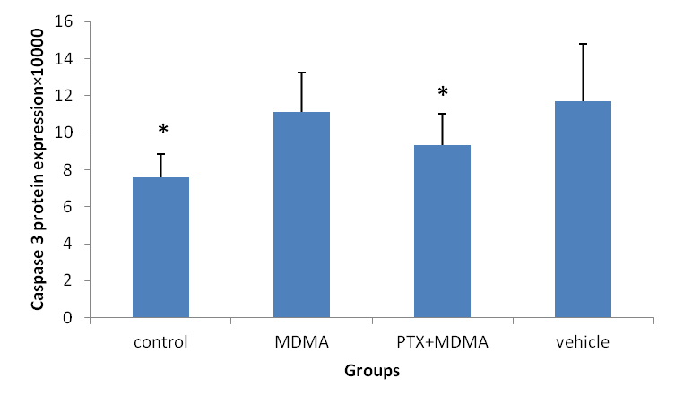

**Figure.3**. Protein expression of cleaved caspase 3 in the hippocampus of vehicle, experimental (PTX+MDMA), MDMA and control groups by western blot. * Expression of caspase-3 protein significantly decreased in the hippocampus of experimental group following PTX (200 mg/kg) treatment vs. MDMA and vehicle groups (P≤0.05). Values are mean±SD.

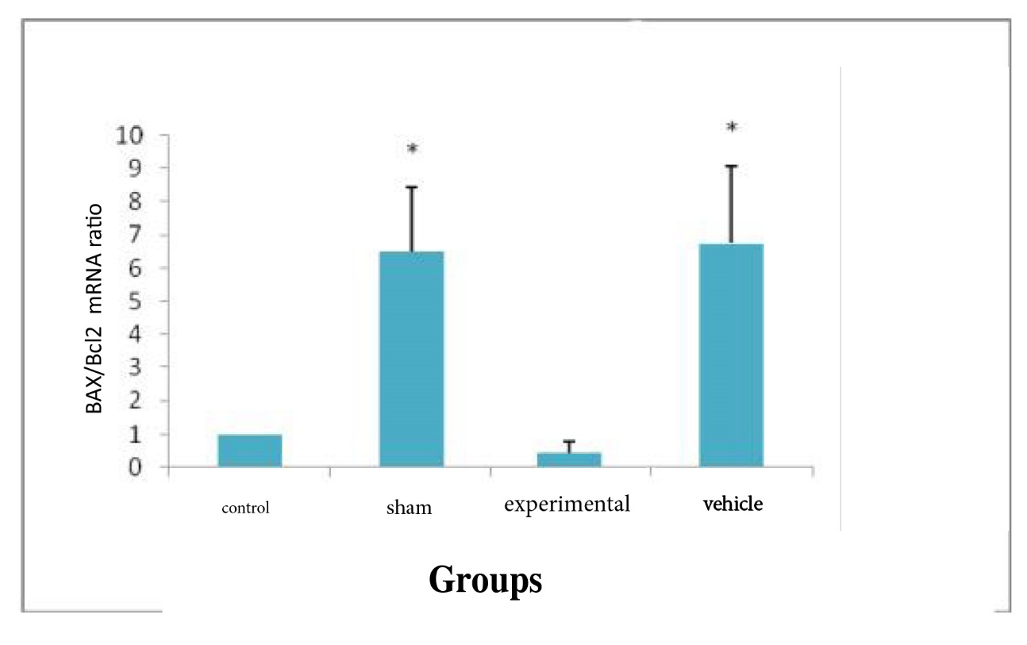

**Figure.4.** BAX/Bcl-2 mRNA ratios in the hippocampus of rats. BAX/Bcl-2 mRNA ratio. *P<0.05. Data are presented as means± SD.